ICDDR,B: Centre for Health & Population Research RRC APPLICATION FORM

FOR OFFICE USE ONLY
Research Protocol RRC Approval: Yes / No Date:
Protocol No.2004-001 ERC Approval: Yes / No Date:
AEEC Approval: Yes / No Date:

Project Title: Effects of frequency of feeding and energy density of complementary foods on total energy intakes and consumption of breast milk by healthy, breastfed children in Bangladesh

Theme: (Check all that apply)
Nutrition Environmental Health
Emerging and Re-emerging Infectious Diseases Health Services
Population Dynamics Child Health
Reproductive Health Clinical Case Management
Vaccine evaluation Social and Behavioural Sciences
HIV/AIDS

Key words: growth faltering, complementary feeding, breast-feeding, energy density, feeding frequency
__________________________________________________________________________________________

Relevance of the protocol:
The proposed study will collect information on the amounts of consumed complementary foods and breast milk and the total energy intake from both the sources; when the children are offered complementary foods of varied energy densities at different feeding frequencies along with ad libitum breast feeding. With this full set of information, it will be possible to develop practical recommendations regarding the design of complementary foods for healthy breast-fed children to permit optimal energy intakes without adversely affecting their consumption of breast milk.

Programmes
Child Health Programme Health and Family Planning Systems Programme
Nutrition Programme Population Programme
Programme on Infectious Diseases & Vaccine Science Reproductive Health Programme
Poverty and Health Programme HIV/AIDS Programme

Principal Investigator: Dr Md Munirul Islam; Division: Clinical Sciences Division;Phone: 8811751-60,Ext.2304

Address: Clinical Sciences Division Email: mmislam@ucdavis.edu

Co-Principal Investigator(s): Kenneth H Brown, MD, UC Davis, U.S.A.

Co-Investigator(s): 1. Tahmeed Ahmed, MBBS, Ph.D. ICDDR,B
2. Kathryn G Dewey, PhD, UC Davis, U.S.A.

Revised on:15th April 2003

Student Investigator/Intern:

Collaborating Institute(s): University of California, Davis, USA

Population: Inclusion of special groups (Check all that apply):
Gender Pregnant Women
Male Fetuses
Females Prisoners
Age Destitutes
0 – 5 years Service providers
5 – 9 years Cognitively Impaired
10 – 19 years CSW
20 – 64 years Others (specify ____________________________)
65 + Animal

Project / study Site (Check all the apply):
Dhaka Hospital Mirsarai
Matlab Hospital Patyia
Matlab DSS area Other areas in Bangladesh ____________________
Matlab non-DSS area Outside Bangladesh
Mirzapur name of country: ________________________
Dhaka Community Multi centre trial
Chakaria (Name other countries involved)
Abhoynagar ______________________________________

Type of Study (Check all that apply):
Case Control study Cross sectional survey
Community based trial / intervention Longitudinal Study (cohort or follow-up)
Program Project (Umbrella) Record Review
Secondary Data Analysis Prophylactic trial
Clinical Trial (Hospital/Clinic) Surveillance / monitoring
Family follow-up study Others

Targeted Population (Check all that apply):

No ethnic selection (Bangladeshi) Expatriates
Bangalee Immigrants
Tribal groups Refugee

Consent Process (Check all that apply):

Written Bengali language
Oral English language
None

Proposed Sample size: Total sample size: ____________18______________

Sub-group ____________________________________ ___________________________________________

_____________________________________________ ___________________________________________

Determination of Risk: Does the Research Involve (Check all that apply):

Human exposure to radioactive agents? Human exposure to infectious agents?
Fetal tissue or abortus? Investigational new drug
Investigational new device? Existing data available via public archives/source
(specify________________________) Pathological or diagnostic clinical specimen only
Existing data available from Co-investigator Observation of public behaviour
New treatment regime

Yes/No
Is the information recorded in such a manner that subjects can be identified from information provided directly or through identifiers linked to the subjects?

Does the research deal with sensitive aspects of the subject's behaviour; sexual behaviour, alcohol use or illegal conduct such as drug use?

Could the information recorded about the individual if it became known outside of the research:

a. place the subject at risk of criminal or civil liability?

b. damage the subject's financial standing, reputation or employability; social rejection, lead to stigma, divorce etc.

Do you consider this research (Check one):

greater than minimal risk no more than minimal risk
only part of the diagnostic test

Minimal Risk is "a risk where the probability and magnitude of harm or discomfort anticipated in the proposed research are not greater in and of themselves than those ordinarily encountered in daily life or during the performance of routine physical, psychological examinations or tests. For example, the risk of drawing a small amount of blood from a healthy individual for research purposes is no greater than the risk of doing so as a part of routine physical examination".

Yes/No

Is the proposal funded?

If yes, sponsor Name: ______________________________________________________________________

Yes/No

Is the proposal being submitted for funding ?

If yes, name of funding agency: (1) __United States Department of Agriculture (USDA)_____________

(2) ___________________________________________________________

Do any of the participating investigators and/or their immediate families have an equity relationship (e.g. stockholder) with the sponsor of the project or manufacturer and/or owner of the test product or device to be studied or serve as a consultant to any of the above?

IF YES, submit a written statement of disclosure to the Director.

Dates of Proposed Period of Support Cost Required for the Budget Period ($)

(Day, Month, Year - DD/MM/YY) a. Ist Year 2nd Year 3rd Year Other years

Beginning date_ June 01, 2004_________ 162,679__ __33,684__ __________ __________

End date November 30, 2005_________ b. Direct Cost :_155,587__ Total Cost : 196,362

Approval of the Project by the Division Director of the Applicant

The above-mentioned project has been discussed and reviewed at the Division level as well by the external reviewers.
The protocol has been revised according to the reviewer’s comments and is approved.

_Dr Mohammad Abdus Salam_ _____________________ _______________________
Name of the Associate Director Signature Date of Approval

Certification by the Principal Investigator
Signature of PI
I certify that the statements herein are true, complete
and accurate to the best of my knowledge. I am aware Date:
that any false, fictitious, or fraudulent statements or
claims may subject me to criminal, civil, or administra- Name of Contact Person (if applicable)
tive penalties. I agree to accept responsibility for the
scientific conduct of the project and to provide the re-
quired progress reports if a grant is awarded as a result
of this application.

Table of Contents

Page Numbers
Face Page……………………………………………………………………………………………………………………….. 1
Project Summary……………………………………………………………………………………………………………… 6
Description of the Research Project
Hypothesis to be tested………………………………………………………………….……………………………… 8
Specific Aims ……………….……………………………………………………………………………………………. 8
Background of the Project Including Preliminary Observations……………………………………….. 9
Research Design and Methods…………………………………………………………………………………….. 13
Facilities Available………………………………………………………………………………………………………. 18
Data Analysis…………………………………………………………………………………………………………….. 18
Ethical Assurance for Protection of Human Rights………………………………………………………….. 19
Use of Animals……………………………………………………………………………………………………………. 19
Literature Cited………………………………………………………………………..…………………………………. 20
Dissemination and Use of Findings……………………………………………………………………………….. 22
Collaborative Arrangements…………………………………………………………..…………………………….. 22
Biography of the Investigators……………………………………………………………………………………… 23
Detailed Budget…………………………………………….……………………………………………………………….. 39
Budget Justifications……………………………………………………………………………………………………… 44
Other Support……………………………………………….…………………………………………………………………
Ethical Assurance : Protection of Human Rights ………….………………………………………………
Appendix…..…………………………………………………………………………………………………………………… 32
Consent Forms in English 34
Consent Forms in Bangla 49

X Check here if appendix is included

PROJECT SUMMARY: Describe in concise terms, the hypothesis, objectives, and the relevant background of the project. Describe concisely the experimental design and research methods for achieving the objectives. This description will serve as a succinct and precise and accurate description of the proposed research is required. This summary must be understandable and interpretable when removed from the main application. (TYPE TEXT WITHIN THE SPACE PROVIDED).

Principal Investigator: Mohammad Munirul Islam

Project Name: Effects of frequency of feeding and energy density of complementary foods on total energy intakes and consumption of breast milk by healthy, breastfed children in Bangladesh

Total Budget: US $ 196,362 Beginning Date: 01 June, 2004 Ending Date: 30 November, 2005

Infants older than 6 months of age, in addition to breast milk, require complementary food of sufficient energy and nutrient densities to meet nutrient requirements. Despite critical importance of appropriate feeding to prevent growth faltering during this particularly vulnerable stage of life, there is little available information on the optimal frequency of feeding and the minimum energy density of complementary foods necessary for ensuring optimal energy requirements. Possible interactions between these two major determinants of total daily energy intake have also been not studied. The impact of different complementary feeding regimens on the amount of breast milk consumption has also not been investigated. To develop practical guidelines for appropriate frequency of feeding and energy density of mixed foods for young, non-breastfed children, a series of clinical studies have previously been designed to measure the total daily energy consumption from cereal-milk mixtures with different energy densities that were fed ad libitum varied numbers of times per day under carefully monitored conditions. These studies were conducted in the recovery phase of hospitalized malnourished children fully weaned from the breast. There is lack of similar information on non-malnourished, breastfed children. Further studies are needed to assess the independent effects of energy density and feeding frequency on energy intake from complementary food and their impact on consumption of breast milk, so that practical recommendations can be developed for healthy, young breast fed children. Before initiation of such studies, information is needed on the time period that is required for stabilization of breast milk intake after introduction of high energy foods to children who have been receiving a low energy diet and vice versa.

We have already conducted a preliminary study to collect information on the effects of dietary energy densities on intake of breast milk by healthy children. We studied 10 children aged 9-18 months with Length-for-Age (ZLA) and Weight-for-Length (ZWL) between -1.5z and 1.5z. They were fed complementary foods (CF) of two energy densities (0.4 kcal/g, as Low Density [LD], and 1.5 kcal/g, as High Density [HD]) 3 times daily along with ad libitum breast-feeding (BF). The diets were fed during three 8-d study periods in random sequence (HD-LD-HD or LD-HD-LD). CF intakes were measured by weighing bowls before and after meals, and BM intakes were measured by test-weighing. We found that despite greater volume of intake of LD CF, energy intake from HD CF was higher at this feeding frequency. BM intake decreased slightly when HD CF was provided, however, total energy intake (CF+BM) was substantially higher. No stabilization period is required for breast milk and the HD diet intake, however 5 days are required for stabilization of the intake of LD. Based on these findings, we designed the proposed study to collect information on the consumption of complementary foods and breast milk, and the total energy intake from both the sources when children are offered complementary foods of varied energy densities at different feeding frequencies along with ad libitum breast feeding. With this complete set of information, it will be possible to develop practical recommendations for complementary feeding of healthy breast-fed children to ensure optimal energy intakes without adversely affecting the consumption of breast milk.

A total of 18 children of either sex, aged 8-11months, who are breastfed at least 6 times/day along with complementary foods having Length-for Age (ZLA) >-2.0z and Weight- for-Length (ZWL) between -1.5z and 1.5z scores (NCHS median) will be enrolled. Field workers will initially identify potentially eligible children according to the eligibility criteria in the community, and observe them at their respective homes for 12 hours on two consecutive days to collect information on consumption on breast milk and other foods. Based on these information the children will be finally admitted to the Research Ward of the Dhaka Hospital of ICDDR,B. All children will be fed a diet containing 1.0 kcal/g three times a day for the first three days to adapt them to the study ward environment and clinical procedures. During the subsequent study periods, complementary foods will be offered three, four or five times a day at pre-determined intervals during sequential diet periods. The sequence of diet periods will be ordered randomly with regard to the frequency of meals. Within each diet frequency period, the order of energy densities of diets (0.5 kcal/g, 1.0 kcal/g, and 1.5 kcal/g of diet) will also be allocated randomly. According to our preliminary study, energy intakes from the diet containing 0.4 kcal/g stabilized by the fifth day of exposure and intakes from diets containing 1.5 kcal/g stabilized by the second day. Thus, in the present study we will offer the lower density diet (0.5 kcal/g) for six days and the two higher energy density diets (1.0 kcal/g and 1.5 kcal/g) for three days each. Data collected during the last two days of each dietary energy density period will be included in the analyses. CF intakes will be measured by weighing bowls before and after meals. Mothers will be advised to breastfeed day and night, following the usual pattern, or more frequently if necessary.

Breast milk intake will be measured by test-weighing. At the beginning and end of each sequence of feeding frequency (i.e., study days 3, 16, 29 and 42), breast milk will be expressed by electric pump for laboratory analysis. On these days (considered as a ‘rest day’), children will be offered the diet containing 1.0 kcal/g three times a day. The body weight will be measured each morning throughout the study period and length will be measured on admission and seven days thereafter. The total duration of study for each mother-child pair will be 42 days.

The primary response variables will be energy intake from complementary foods (kcal/kg.day), energy intake from breast milk (kcal/kg.day), and total energy intakes from both sources. The total time required for feeding episodes and frequency and duration of breastfeeding will also be examined. Data from days 5 and 6 for the lower energy density (0.5 kcal/g) diet and days 2 and 3 for the two higher energy density diets (1.0 kcal/g and 1.5 kcal/g) will be analyzed. Descriptive statistics (mean, standard deviation, minimum, maximum, median) will be calculated for all continuous variables, and outcome variables will be transformed, if appropriate, to conform to the assumption that error terms are normally distributed. The data will be analyzed with the SAS General Linear Model procedure, using a mixed model analysis of variance after first confirming the normal distribution of the dependent variables or completing any necessary transformations of data. The main effects that will be included in the models are dietary energy density (3 levels), frequency of feeding (3 levels), individual (random) effects, and the two-way interactions between energy density and feeding frequency.

KEY PERSONNEL (List names of all investigators including PI and their respective specialties)

Name Professional Discipline/ Specialty Role in the Project

1. Md. Munirul Islam Medical Officer, ICDDR, B/Nutrition Principal Investigator
2.Tahmeed Ahmed Associate Scientist, ICDDR, B/Nutrition; child health Co-investigator
3. Kathryn G. Dewey Professor, UC Davis/Nutrition Co-investigator
4. Kenneth H. Brown Professor, UC Davis/Nutrition Co-investigator

DESCRIPTION OF THE RESEARCH PROJECT

Hypothesis to be tested:

Concisely list in order, in the space provided, the hypothesis to be tested and the Specific Aims of the proposed study. Provide the scientific basis of the hypothesis, critically examining the observations leading to the formulation of the hypothesis.

1a. At any level of feeding frequency of complementary food, the amount of complementary food intake by breastfed children will be greater when the energy density of complementary food is lower.

1b. At any level of dietary energy density, the amount of complementary food intake by breastfed children will increase with increasing feeding frequency.

1c. At any level of feeding frequency of complementary food, the energy intake from complementary food by breastfed children will be greater when the energy density of complementary food is higher.

1d. At any level of dietary energy density, the energy intake from complementary food by breastfed children will be higher when the frequency of feeding of complementary food is also higher.

2a. At any level of feeding frequency of complementary food, the energy intake from breast milk will be less when the energy density of complementary food is higher.

2b. At any level of dietary energy density, the energy intake from breast milk will be less when frequency of feeding of complementary food is higher.

3a. At any level of feeding frequency of complementary food, the total energy intake by breastfed children will be higher when the energy density of complementary food is also higher.

3b. At any level of dietary energy density, the total energy intake by breast fed children will be higher when the frequency of feeding of complementary food is higher.

Specific Aims:

Describe the specific aims of the proposed study. State the specific parameters, biological functions/ rates/ processes that will be assessed by specific methods (TYPE WITHIN LIMITS).

- To observe a community for identification of breastfed children between 8-11 months of age who are eligible for recruitment into the study.

- To assess if children’s dietary intake at home conforms to eligibility criteria of the study.

- To admit 18 eligible children and their mothers, and measure total ad libitum energy consumption by these children when they receive defined complementary foods of varied energy densities 3, 4 or 5 times per day during sequential dietary periods.

- To measure the total ad libitum consumption of breast milk, and total nursing frequency and time by these same children.
Background of the Project including Preliminary Observations

Describe the relevant background of the proposed study. Discuss the previous related works on the subject by citing specific references. Describe logically how the present hypothesis is supported by the relevant background observations including any preliminary results that may be available. Critically analyze available knowledge in the field of the proposed study and discuss the questions and gaps in the knowledge that need to be fulfilled to achieve the proposed goals. Provide scientific validity of the hypothesis on the basis of background information. If there is no sufficient information on the subject, indicate the need to develop new knowledge. Also include the significance and rationale of the proposed work by specifically discussing how these accomplishments will bring benefit to human health in relation to biomedical, social, and environmental perspectives. (DO NOT EXCEED 5 PAGES, USE CONTINUATION SHEETS).

In developing countries, children’s weight gain commonly falters between 3-15 months of age - a period when complementary food is usually added to their diets (1). The primary explanations for children’s poor growth during this period include insufficient or inappropriate dietary intakes and frequent infections. To meet their physiological requirements, infants older than 6 months of age require complementary foods of appropriate energy and nutrient densities in addition to breast milk. The high-energy requirements of young children, together with their limited stomach capacity, make it difficult for them to eat large volume of food, particularly if the energy density of the diet is low or if only a few meals are consumed each day (2,3,4). Quantitative studies of energy intake by weanlings have shown that older infants and young children in developing country settings often consume substantially less than internationally recommended amounts (5-10), which are based on observations of energy expenditure and growth of older infants and young children in industrialized countries (11-13). Possible explanations for lower energy intakes by children in developing countries include limited household food availability; less frequent feeding, energy density of diets, or amount of food offered; and reduced appetite of children due to infections or nutrient imbalance (14). Feeding frequency and dietary energy density are independently related to total daily energy intake, and thus both need to be considered in developing recommendations for infant feeding (2). When meals are provided multiple times a day, energy requirements can be met with diets of lower energy density; and conversely when fewer meals are offered the diets have higher energy density to provide adequate energy intake.

The effects of feeding frequency and dietary energy density on total daily energy intakes have been studied in fully weaned children recovering from malnutrition (2); however, there is lack of similar studies in healthy breast-fed children. To develop appropriate recommendations for breastfed children, the potentially adverse effects on breast milk intake that might be imposed by overly frequent feeding or feeding diets with excessively high energy density must also be considered. It is conceivable that unnecessarily higher intakes of complementary food will suppress children’s desire to nurse at the breast, influencing overall quality of their diets and exposing them to food-borne pathogens, and hastening maternal return to fertility. Studies indicate that breast milk intake is controlled by the infants’ appetite and the duration of suckling, and nursing frequency influences milk production in several ways including both endocrine and autocrine mechanisms (15-17). Increased frequency of nursing may, therefore, lead to greater milk production, and vice versa.

To develop optimal feeding recommendations for breastfed children during the period of complementary feeding, further studies are needed to assess the independent effects of energy density and feeding frequency of complementary foods on both energy intakes from such foods and on breast milk intake. In better designing such a study, we have recently completed a preliminary study to determine the number of days required for stabilization of breast milk intake after introduction of high energy density complementary foods (CFs) to the diet of children who had been receiving low energy CFs and vice versa. The results of these preliminary studies are described in the following section.

Preliminary Study: This study was conducted to determine the number of days required for stabilization of the intake of both complementary foods and breast milk after introduction of foods with varied energy density. Ten children aged 9-18 months were studied, and all had weight-for-length Z-scores (WLZ) and height-for-age Z-scores (HAZ) >-1.5 Z and <1.5 Z. During each of three separate 8-day dietary periods, children were fed complementary food of either of the two different energy densities [0.4 kcal/g, regarded as low density (LD), and 1.5 kcal/g, regarded as high density (HD)] three times daily in addition to ad libitum breast-feeding. The respective diets were fed in random sequence (HD-LD-HD or LD-HD-LD) for 8 days during each of three study periods, and the amounts of food and breast milk intake were measured. The data for study days 5-7 of each of the last two dietary periods are presented here. Overall, the children consumed significantly larger volume of LD diet than the HD diet (752 ± 252 vs. 439 ± 111 g/d, and 87.9 ± 27.2 vs. 50.1 ± 12.5 g/kg.day respectively; p<0.0001) [Figures 1 and 2], but they received significantly higher amount of energy from the HD diet than from LD diet (75.2 ± 18.8 kcal/kg vs. 35.2 ± 10.9 kcal/kg.day; p<0.0001). When the intakes of CF were compared by day of dietary period within each dietary period, there were no differences observed within the HD diet period (p=0.39); however, total daily consumption from LD diet tended to increase during the first five days of the dietary period before reaching a plateau. Children consumed more breast milk during periods when they received the LD diet compared with the periods when they received the HD diet (234 ± 121 vs. 192 ± 115 g/d; p=0.03). There were no significant differences in the amount of breast milk consumed by the day of the dietary period for either of the CFs (p= 0.153) [Figure 3].

The total daily energy intake, from both breast milk and complementary foods, was greater when the children were fed the HD diet than the LD diet (88.3 ± 19.5 kcal/kg.day vs. 52.0 ± 9.8 kcal/kg.day; p <0.0001) despite small decrease in breast milk intake associated with feeding of HD diet [Figure 4].

The results of this preliminary study has enabled us to design a more definitive trial with a broader range of feeding frequencies and energy densities of complementary foods to assess their effects on consumption of CFs, breast milk intake, and on daily energy intakes. With this complete set of information, it will be possible to formulate practical recommendations on designing complementary foods for healthy breast-fed children for optimal energy intakes without adversely affecting their consumption of breast milk.

Figure 1 – Amount of complementary food consumed (g/d) by dietary energy density and day of study

Figure 2 – Amount of complementary food consumed (g/kg BW/d) by dietary energy density and day of
Study

Figure 3 – Amount of breast milk consumed (g/d) by dietary energy density and day of study

Figure 4 – Total daily energy intake (kcal/kg BW/d) by dietary energy density and day of study

Research Design and Methods

Describe in detail the methods and procedures that will be used to accomplish the objectives and specific aims of the project. Discuss the alternative methods that are available and justify the use of the method proposed in the study. Justify the scientific validity of the methodological approach (biomedical, social, or environmental) as an investigation tool to achieve the specific aims. Discuss the limitations and difficulties of the proposed procedures and sufficiently justify the use of them. Discuss the ethical issues related to biomedical and social research for employing special procedures, such as invasive procedures in sick children, use of isotopes or any other hazardous materials, or social questionnaires relating to individual privacy. Point out safety procedures to be observed for protection of individuals during any situations or materials that may be injurious to human health. The methodology section should be sufficiently descriptive to allow the reviewers to make valid and unambiguous assessment of the project. (DO NOT EXCEED TEN PAGES, USE CONTINUATION SHEETS).

Study design: This would be a double blind clinical trial to observe intra-individual differences in energy intake from complementary food and breast milk during sequential dietary periods in which the order of presentation of the feeding regimens would be randomly assigned to individual children.

Study site: The study will be conducted in the Research Ward of the Clinical Research and Services Centre (CRSC; Dhaka Hospital) of the International Centre for Diarrhoeal Disease Research, Bangladesh (ICDDR, B), in Dhaka, Bangladesh.

Subjects: Healthy children of either sex, aged 8-11 months, who are reportedly breastfed at least 6 times/day and receive complementary foods at least 2 times/day will be invited for further screening if they have Length-for-Age Z-score (LAZ) >-2.0 Z Weight-for-Length Z-score (WLZ) between -1.5Z and 1.5Z of NCHS median and their mothers have a Body Mass Index (BMI) >18.5 kg/m². Children with any acute or chronic illness or congenital anomalies will be excluded, and so will be the children who are exclusively breastfed, exclusively formula fed, or fully weaned.

Recruitment of study participants:

- Initial identification and selection: Field workers dedicated to this study will conduct a survey in the communities close to the study site (preferably in Nandipara, Dhaka) to identify children who are potentially eligible to participate, based on the above laid down criteria. The parents of such children will be invited to enrol their children in the study after fully informing them on the purpose and methods of the study as well as its potential risks and benefits, and if willing to participate the children and their mothers will be brought to the study site. Study Research Assistants will confirm earlier information on feeding practices and perform anthropometric assessments. Children meeting eligibility criteria will then be invited to participate in further dietary studies, as explained below, after obtaining written informed consent of either of the parents:

- Studies of dietary intake at home: In our preliminary study, we observed that some children, who were reportedly consuming breast milk at least 6 times/day at home, actually received breast feeds less frequently while admitted to the study ward. We do not know if this difference reflects the effects of consuming the complementary foods provided under the study or exaggeration of the number of breastfeeds during the initial interview for undetermined reason(s). To avoid recurrence of this problem in the proposed study, we plan to complete, on two occasions, 12-hour observations of the frequency of nursing, amount of breast milk consumed and number of servings of complementary foods that are provided at home before the final selection of the study participants. The Research Assistants will perform these observations by staying at the respective homes, and record feeding frequency, and weigh raw ingredients used in the preparation of complementary foods before cooking, and measure their weight before and after feeding to determine the amount consumed. The energy values of the complementary foods will be calculated from food composition tables. The Research Assistants will also record the breastfeeding frequency and will test-weigh the child each time s/he is nursed at the breast, to measure the amount of milk consumed. The energy value of the breast milk will be estimated using the information obtained from previous studies (18). The 12-hour test weighing data will be extrapolated to estimate the 24 h milk volume (18).

- Final selection criteria: After collection of dietary data during the home observations, as described above, the Principal Investigator/Medical Officer will finally determine the eligibility of the children for participation in the study based on the intake of complementary foods and breast milk, using the following criteria:

  - Frequency of consumption of complementary foods: > 2 meals/day

  - Energy intake from complementary foods: >85 kcal/day [The rationale for this criterion is based on data from longitudinal studies of US children (Butte NF, prepared for ‘FAO/WHO/UNU Working Groups on Energy and Protein in Human Nutrition’), which showed that total energy intake by children 9-11 months of age was 686 kcal/day, and data from the WHO publication, “Complementary Feeding of Young Children in Developing Countries,” which indicated that the amount of energy consumed by high breast milk consumers (mean + 2SD) is 601 kcal/day. Thus, the minimum energy required from complementary food is set at 686-601= 85 kcal/day] (19)

  - Breast feeding frequency: > 6 times/day

  - Breast milk intake: >262 g/d (>157 kcal/day). [The rationale for this criterion is based on data from the same WHO review, which indicate that the energy intake from breast milk by children 9-11 months of age is 379 ± 111 kcal/day. Thus, we would expect low breast milk consumers (mean – 2SD), to receive at least 157 kcal/day from breast milk (19) which is equivalent to about 262 g/d, considering the energy density of breast milk to be 0.6 kcal/g, as has been reported for developing countries (19).]

Study ward procedures

Adaptation period: During the adaptation period i.e. the first three days after admission to the Research Ward, the study children will receive a study diet with energy density of 1.0 kcal/g to confirm that they will accept the study diets and comply with the study procedures (In our preliminary study all but one of the children admitted to the study ward accepted the study diets). If any child continuously refuses to consume the study diet within two days of admission to the ward, s/he will be excluded from the remainder of the study, discharged from the hospital with advice, if necessary, and such children will be replaced by recruitment of other eligible children.

Dietary energy densities and frequency of serving: Diets will be prepared at three levels of energy densities, 0.5, 1.0 and 1.5-kcal/g of diet, and each will be served 3, 4 or 5 times per day during separate dietary periods.

Description of diets: Semi-solid study diets of varied energy densities will be prepared from the same relative amounts of rice powder, rice starch, milk powder and soybean oil but varying amounts of water to achieve different levels of energy densities. These rice-based purees are similar to those routinely used at the CRSC (Dhaka Hospital) for children of the same age group. To mask the consistency of the diets prepared at different energy densities, α-amylase will be added to the higher density diets (i.e., diets of 1.0 kcal/g and 1.5 kcal/g) to match the viscosity of the lowest density diet. Sweetening, flavoring and coloring agents will be added, as needed, to the lower density diets to standardize the organoleptic characteristics. In our preliminary study, we prepared food in a similar way, and the composition of the study diets is shown in Appendix 1.

The study participants will also receive a daily vitamin-mineral supplement (1/2 tablet Centrum kids, Wyeth Laboratories, USA) to provide 2,500 IU vitamin A (20% as β-carotene), 30 mg vitamin C, 200 IU vitamin D, 15 IU vitamin E, 5 μg vitamin K, 0.75 mg thiamine, 0.85 mg riboflavin, 10 mg niacin, 1 mg vitamin B₆, 200 μg folic acid, 3 μg vitamin B₁₂, 22 μg biotin, 5 mg pantothenic acid, 54 mg calcium, 9 mg iron, 25 mg phosphorous, 75 μg iodine, 20 mg magnesium, 7.5 mg zinc, 1 mg copper, 0.5 mg manganese, 10 μg chromium, and 10 μg molybdenum. The half tablet will be crushed and added to the first 1-2 spoonfuls of the breakfast meal each day.

Preparation of diets: Research Assistants will prepare the study diets, separately for each child, in a special metabolic kitchen under the supervision and guidance of a hospital dietician. Each day’s diet will be supplied to the Research Ward in pre-coded containers for each study participant and stored in a refrigerator until the time of serving. The meals will be re-warmed to body temperature in a microwave oven just before serving.

Feeding protocol: As indicated above, all children will be fed a diet containing 1.0 kcal/g three times a day for the first 3 days of admission to the Research Ward, to allow them to adapt to the study ward environment and the study procedures. During the subsequent study periods, complementary foods will be offered 3, 4 or 5 times per day at pre-determined intervals during each of the sequential diet periods. The sequence of the diet periods will be randomly ordered with regard to the frequency of meals. Within each diet frequency period, the order of energy densities will also be randomly allocated. According to our preliminary study (22), energy intakes from the diet containing 0.4 kcal/g stabilized by the 5th day of exposure and intakes from diets containing 1.5 kcal/g stabilized by the 2nd day. In a previous study, intake of a diet containing 1.0 kcal/g also stabilized within 2 days (14). Thus, in the proposed study we will offer the lower density diet (0.5 kcal/g) for 6 days and the two higher energy density diets (1.0 kcal/g and 1.5 kcal/g) for 3 days each. Data collected during the last 2 days of each dietary period will be included in the analyses. At the beginning and end of each sequence of feeding frequency (i.e., study days 3, 16, 29 and 42), breast milk will be expressed for laboratory analysis. On these days (considered as a ‘rest day’), children will be offered 1.0 kcal/g diet 3 times per day. An example of the dietary sequences is shown in Appendix 2.

Children with fever or diarrhea, at any point during the course of the study, will be removed from the protocol on that day and will be offered the 1.0 kcal/g diet three times a day for as long as the symptoms persists. After two complete, symptom-free days, the study protocol will be resumed considering that as the first day of the same pre-illness density/frequency. Any child becoming ill during the study will be treated according to the standardized management protocols of the CRSC (Dhaka Hospital) of ICDDR, B.

During each study period, the mothers will be asked to spoon feed their children ad libitum the respective diets until the child refuses to eat further, as described below. After a two-minute delay, the same diet will be offered a second time until refused again. After a second two-minute delay, the diet will be offered a third time until refused again. After this third refusal, the feeding episode will be considered terminated. The duration of the feeding (excluding the intervening ‘rest periods’) will be recorded by stopwatch, and the total duration of the feeding will be noted.

Children will be considered as refusing further intake if they move their head away from the food, cry, clamp the mouth or clinch the teeth, or become agitated, spit out the food or refuse to swallow (20,21).
Measurement of complementary food intake: All feeding episodes will take place under the supervision of study personnel. Food portions will be weighed before and after serving using an electronic balance with one-gram precision, and the actual amount consumed will be calculated by subtracting leftover food from the amount offered. Pre-weighed napkins will be provided; any food that is regurgitated, vomited or spilled will be swabbed, weighed and subtracted from the amount offered.

Measurement of breast milk intake: Mothers will be requested to breastfeed day and night, according to the usual feeding pattern at home prior to the study or more frequently if the child demands. Mothers will be asked to wear a bra at night to avoid the possibility that the infants might initiate a feed without the mother’s knowledge. At each nursing, breast milk will be offered until the child refuses further intake, and the amount consumed will be measured by test-weighing before and after nursing, while ensuring that the child wears the same clothing for each weighing. Each nursing episode initiated after taking a post-feeding weight will be considered a new episode, and the intake will be similarly measured. Breast milk intake will be measured by recording the difference in the child’s weight before and after the feed, using an electronic balance with one-gram precision, and the weight change will be adjusted for child-specific insensible losses, which will be measured on the same balance for at least 30 minutes each day. The duration of each episode of breast-feeding will be measured using a stopwatch, and the duration and frequency of breastfeeding in 24 hours will also be recorded.

Collection of breast milk for laboratory assay: To obtain representative samples of milk for analysis of energy content, breast milk will be expressed with an Ameda/Egnell mechanical pump for 24 hours on days 3, 16, 29 and 42 (at baseline and after each sequence of feeding frequency), using the alternate breast expression method (22). Aliquots of milk representing ~10% of each expressed sample will be saved, pooled over 24 hours, and stored in freezer at -20°C until subsequent analysis. The remaining ~90% of the milk will be fed to the child by cup and spoon shortly after each expression.
Laboratory assay of breast milk: Milk samples will be analyzed in the laboratory of the University of California, Davis for total and non-protein nitrogen (micro-Kjeldahl), lactose (enzymatic determination), and fat (gravimetric determination following Folch extraction) (23). Milk energy contents will be calculated from the concentrations of fat, lactose, and protein nitrogen, using previously published methods (22).

Anthropometric Measurements: The infants’ nude body weight will be measured at admission and each morning during the entire study period. Length will be measured at admission and weekly thereafter, using an infantometer with 0.1 cm increments.

Sample size estimation: The sample size is estimated based on the observed mean (±SD) energy intakes from complementary foods and breast milk during our preliminary study ((21). For these analyses we considered the mean intakes of each energy source on days 2-3 of the HD diet period and days 5-6 of the LD diet period (Intake of CF 618±111 g/day, 525±109 kcal/d; intake of BM 225±78 g/d and total energy intake 660±108 kcal/d). A sample size of 18 children will permit detection of a 15% difference in mean daily energy intake from breast milk, a 9% difference in mean daily energy intake from complementary food, an 8% difference in mean daily intake of complementary food, and a 7% difference in total daily energy intake in relation to any permutation of energy density or feeding frequency at a 5% level of significance and 80% power. This sample size of 18 also permits a balanced study design because 3 children will be allocated to each of the possible permutations of feeding frequency. The subject recruitment will continue until we are able to collect data from 18 mother-child pairs. In other words, if any mother-child pair is unable to complete the study, another pair will be recruited to replace the one that departed.

Duration of study: The total duration of study for each mother-child pair will be 42 days.

Logistics: In our preliminary study, we screened 60 children, 9-18 months of age and their mothers to assess their eligibility for participation in the study with regard to their nutritional status, reported feeding history, and maternal BMI. Of these, 10 mothers and children fulfilled the entry criteria and were willing to participate in the study. Based on this experience, we anticipate that we will need to identify ~220 children of the appropriate age range during the community census to select ~36 mothers and children, (i.e., ~16%) who might be eligible for the study as well as willing to participate. These 36 children will then be included in the home observational studies of dietary intake, and we estimate that at least half of these (i.e., 18 children) will be eligible for the clinical studies.

Home observation study: Two separate 12-hour home observation studies will be conducted in the homes of these 36 potentially eligible children over the course of 7 months. Therefore, dietary observations will be conducted in ~5 children each month and the total number of home studies will be 10 days per month.

Clinical studies in the research ward: There will be a total of 18x42=756 days of clinical study. Three children will be admitted to the study ward at any given time. Therefore, we will need to conduct 6 rounds of these studies (3 x 6 = total 18 children) to complete the entire clinical phase of the project, which will have a total duration of 6x42 days=252 days, or ~9 months.

Incentives to study subjects: The parents of the study subjects will receive 275 Taka/day (Approximately US $ 5.00/day) as compensation for potential wages lost during their hospital stay. If they withdraw their child from this study before it is completed, they will still receive the compensation for the number of days the child participated in the study. All meals will be provided to the child and their mother would be free of charge during the course of the study, and appropriate evaluation and treatment, if required, would also be provided free of costs.

Limitations: There are several possible limitations of this proposed study, as described in the following section:
Nutritional status of the study subjects: The study will be restricted to children whose weight and length fall within a normal range of nutritional status (length-for-age Z-score >-2 Z and weight-for-length Z-score >-1.5 Z and <1.5 Z). The rationale for this decision is to permit development of recommendations that will be appropriate for the majority of reasonably well-nourished children, without introducing possible variability in study results that might be occasioned by the inclusion of malnourished subjects. Future studies might be necessary to determine if modifications of the recommendations would be necessary for malnourished children.

Study diets: To restrict the number of variables (such as dietary diversity and sensory properties of the diet) that might independently affect children’s intake, we have elected to present a single cereal-based porridge throughout the study. We recognize that children typically do not consume such a monotonous diet at home, but we have chosen not to complicate the interpretation of the study results by offering multiple different preparations. In order to avoid the problem of taking the study diets as the model diet by the mothers, they will be counseled to offer a variety of foods to their children when they return home. The mothers and children will remain in the ward for one additional day at the end of the study so the staff can teach the mothers to use baby food grinders and to prepare a variety of different suitable CF preparations, using locally available foods.

Facilities Available

Describe the availability of physical facilities at the place where the study will be carried out. For clinical and laboratory-based studies, indicate the provision of hospital and other types of patient’s care facilities and adequate laboratory support. Point out the laboratory facilities and major equipments that will be required for the study. For field studies, describe the field area including its size, population, and means of communications. (TYPE WITHIN THE PROVIDED SPACE).

Facilities at ICCDR, B
The study would be carried out at the Research Ward of the Clinical Research and Service Centre (CRSC; Dhaka Hospital) of ICDDR, B. This ward, supported by trained research officer, dieticians, nurses and health workers, is in existence since last several decades. A large number of nutritional/ metabolic balanced studies have been conducted in this ward, and currently at least 3-4 different studies of this nature are being conducted at this ward at any given time. The ward has electronic weighing scales and precision balances required for metabolic balance studies.

Facilities at UC Davis
The University of California Davis is a part of the University of California System, which is globally recognized for its excellence in education and research. The Nutrition Department of UC Davis has a collaborative arrangement with ICDDR, B and provides training to its staff at various levels. A number of research projects on vitamin A have been successfully completed as a joint venture between the two institutions in the recent years. The breast milk samples of the children participating in the study will be sent to UC Davis for the assessment for total and non-protein nitrogen (micro-Kjeldahl), lactose (enzymatic determination), and fat (gravimetric determination following Folch extraction). Milk energy contents will be calculated from the concentrations of fat, lactose, and protein nitrogen. The laboratory of UC Davis has all technical facility for conducting the experiments.

Data Analysis

Describe plans for data analysis. Indicate whether data will be analyzed by the investigators themselves or by other professionals. Specify what statistical software packages will be used and if the study is blinded, when the code will be opened. For clinical trials, indicate if interim data analysis will be required to monitor further progress of the study.
(TYPE WITHIN THE PROVIDED SPACE).

The primary response variables will be energy intake from complementary foods (kcal/kg.day), energy intake from breast milk (kcal/kg.day), and total energy intakes (kcal/kg.day) from both sources. The total time required for feeding episodes, and the frequency and duration of breastfeeding will also be examined. Data from days 5 and 6 for the lower energy density (0.5 kcal/g) diet, and days 2 and 3 for the 2 higher energy density diets (1.0 kcal/g and 1.5 kcal/g) will be analyzed. Descriptive statistics (mean, standard deviation, minimum, maximum, and median) will be calculated for all continuous variables, and outcome variables will be transformed, if appropriate, to conform to the assumption that error terms are normally distributed. The data will be analyzed with the SAS General Linear Model procedure, using a mixed model analysis of variance after first confirming the normal distribution of the dependent variables or completing any necessary transformations of data. The main effects that will be included in the models are dietary energy density (3 levels), frequency of feeding (3 levels), individual (random) effects, and the two-way interactions between energy density and feeding frequency. All tests will be performed at the 5% level of significance.

The investigators will analyze data.

Ethical Assurance for Protection of Human Rights

Describe in the space provided the justifications for conducting this research in human subjects. If the study needs observations on sick individuals, provide sufficient reasons for using them. Indicate how subject’s rights are protected and if there is any benefit or risk to each subject of the study.

This study will be conducted on healthy breast-fed children. The information obtained from this study will be used to develop practical recommendations regarding the design of complementary foods for healthy breast-fed children to permit optimal energy intakes without adversely affecting their consumption of breast milk. As new drugs will not be tested, conduction of this study in human subjects is justified.

The study procedures should not produce any major risk to the health of the study children. It is possible that during the period of the lower energy value diet, the children will want to suck more at the breast and vice versa. Previous studies found that the amount of milk consumed will return to previous levels when the usual home diet is resumed. Many previous studies have used the same kind of pump that will be using to express breast milk, and no harmful effects of this procedure have been reported. At the end of the study, the mothers will be taught how to prepare a variety of diets that they can be offer to the children when they return home.

Participating in this study may not personally benefit the child and/or the mother. However, the results of this study will help in developing guidelines for recommending diets for the young, breast-fed children. As this is a very low risk study with considerable potential benefits for society at large, the risk-benefit ratio is deemed to be favorable.

Use of Animals

Describe in the space provided the type and species of animal that will be used in the study. Justify with reasons the use of particular animal species in the experiment and the compliance of the animal ethical guidelines for conducting the proposed procedures.

No animals will be used for this study.

Literature Cited

Identify all cited references to published literature in the text by number in parentheses. List all cited references sequentially as they appear in the text. For unpublished references, provide complete information in the text and do not include them in the list of Literature Cited. There is no page limit for this section, however exercise judgment in assessing the “standard” length.

- Shrimpton R, Victoria CG, de Onis Mercedes, Lima RC, Blössner M, Clugston G (2001). Worldwide timing of growth faltering: Implications for nutritional interventions. Pediatrics. 107(5):E75.

- Brown KH, Sanchez-Griñan M, Perez F, Peerson JM, Ganoza L, Stern JS (1995). Effects of dietary energy density and feeding frequency on total daily energy intakes of recovering malnourished children. Am J Clin Nutr 62: 13-8

- Svanberg U (1987). Dietary bulk in weaning foods and its effect on food and energy intake. In:Improving young child feeding in Eastern and Southern Africa. Household-level food technology. Proceedings of a workshop held in Nairobi, Kenya. 12-16 October, pp. 272-287

- Kingamkono RP (1987). Effect of food consistency on nutrient intake in young children. Improving young child feeding in Eastern and Southern Africa. Household level food technology. Proceedings of a workshop held in Nairobi, 12-16 October, pp. 312-321

- Gopaldas T (1975). Project Poshak, vol.2. New Delhi, India: Verendra Printers.

- Mata L (1978). The children of Santa Maria Cauque. Cambridge, MA: MIT Press.

- Van Steenberg WM, Kustin JA, Voorhoeve AM & Jansen AAJ (1980). Measured food intake of preschool children in Machakos district. E Afr Med J 57:735-744

- Brown KH, Black RE, Becker S, Nahar S & Sawyer J (1982). Consumption of foods and nutrients by weanlings in rural Bangladesh. Am J Clin Nutr 36: 878-889.

- Brown KH, Dickin KL, Bently ME, Oni GA, Obasaju VT, Esrey SA, Mebrahtu S, Alade I & Stallings RY (1988). Consumption of weaning foods from fermented cereals in Kwara State, Nigeria. In: Improving young child feeding in eastern and southern Africa. Household-level food technology, eds D Alnwick, S Moses, OG Schimidt, pp. 181-197. Canada: International Development Research Centre.

- Creed de Kanashiro H, Brown KH, Lopez de Romana G, Lopez T & Black RE (1990). Consumption of food and nutrients by infants in Huascar (Lima), Peru. Am J Clin Nutr 52: 995-1004.

- World Health Organization (1985). Energy and protein requirements. Report of a joint FAO/WHO/UNO Expert Consultation (Technical Report Series 724). Geneva: World Health Organization.

- Food and Nutrition Board, Committee on Dietary Allowances, Nutritional Research Council (1989). Recommended Dietary Allowances, 10th edn. Washington, DC: National Academy Press.

- Butte NF (1996): Energy requirement of infants. Eur J Clin Nutr 50(1 Suppl): S24-S26

- Sanchez-Griñan MI, Peerson JM, Brown KH (1992): Effect of dietary energy density on total ad-libitum energy consumption by recovering malnourished children. Eur J Clin Nutr 46: 197-204

- Neville MC, Neifert MR (1983). Lactation: physiology, nutrition and breast-feeding. New York, Plenum Press.

- Daly SE, Hartmann PE (1995). Infant demand and milk supply. Part 1: Infant demand and milk production in lactating women. Human Lactation 11: 21-26

- Daly SE, Hartmann PE (1995). Infant demand and milk supply. Part 2: The short-term control of milk synthesis in lactating women. Human Lactation 11: 27-37

- Brown KH, Black RE, Robertson AD, Akhter NA, Ahmed MG, Becker S (1982). Clinical and field studies of human lactation: methodological considerations. Am J Clin Nutr 35:745-756

- Brown KH, Dewey KG, Allen LH (1998). Complementary feeding of young children in developing countries: a review of current knowledge. pp 47 (Table 7).

- Stephenson DM, Meeks JM, Walker SP, Ashworth A (1994). Weaning-food viscosity and energy density: their effects on ad libitum consumption and energy intakes in Jamaican children. Am J Clin Nutr 60: 465-9

- Islam MM, Peerson JM, Ahmed T, Dewey KG, Brown KH. (2003). Effects of energy density of complementary foods on total energy intakes by healthy, breastfed children in Bangladesh: a preliminary study. The FASEB Journal, Part II, A1199 (Experimental Biology, Abstract 768.1).

- Garza C, Butte NF, Dewey KG (1985). Determination of the energy content of human milk. In: Jensen RG, Neville MC (eds), Human Lactation, New York: Plenum Press, pp 121-126

- Polberger S, Lönnerdal B (1993). Simple and rapid macronutrient analysis of human milk for individualized fortification: basis for improved nutritional management of very-low-birth-weight infants? J Pediatr Gastroenterol Nutr 17(3): 283-90.

- Dewey KG, Brown KH (2003): Update on technical issues concerning complementary feeding of young children in developing countries and implications for intervention programs. Food and Nutr Bull 24: 5-28.

Dissemination and Use of Findings

Describe explicitly the plans for disseminating the accomplished results. Describe what type of publication is anticipated: working papers, internal (institutional) publication, international publications, international conferences and agencies, workshops etc. Mention if the project is linked to the Government of Bangladesh through a training programme.

The results of this study will be reported in relevant scientific seminars and meetings, and published in regional and international journals. The results of the study will provide information on the independent effects of energy density and feeding frequency on energy intake from complementary food and breast milk, so that practical recommendations can be developed for healthy, young breast fed children.

Collaborative Arrangements

Describe briefly if this study involves any scientific, administrative, fiscal, or programmatic arrangements with other national or international organizations or individuals. Indicate the nature and extent of collaboration and include a letter of agreement between the applicant or his/her organization and the collaborating organization. (DO NOT EXCEED ONE PAGE)

This is a collaborative proposal with the University of California at Davis. The PI is currently doing doctoral training in the Program in International Nutrition, Department of Nutrition at Davis, and he will conduct the study after completion of required course work of his training. The data obtained from this study will be used for his doctoral dissertation.
Biography of the Investigators

Give biographical data in the following table for key personnel including the Principal Investigator. Use a photocopy of this page for each investigator.

Name: Dr Md Munirul Islam

Clinical Sciences Division, ICDDR, B: Centre for Health & Population Research, Mohakhali, Dhaka 1212, Bangladesh
Telephone No. 88 02 881 1751-60, Extn. 2331, Fax No. 88 02 881 2336
Email: mmislam@ucdavis.edu, mislam@icddrb.org

Current Appointments

Medical Officer, Clinical Sciences Division, ICDDR, B: Centre for Health & Population Research, Dhaka, Bangladesh
Graduate Student, Program in International Nutrition, Department of Nutrition, University of California, Davis, California, USA

Academic Qualification

1987-1994 MBBS (Bachelor of Medicine and Bachelor of Surgery), Dhaka Medical
College, Dhaka, Bangladesh
2001- PhD Student, Program in International Nutrition, Department of Nutrition, University of California, Davis, California, USA

Training and Professional Experiences

  - One-year full time Residential Internship from Dhaka Medical College Hospital, Dhaka, Bangladesh

  - Study Medical Officer of a research protocol entitled “Vegetable protein sources for refeeding
malnourished children during recovery from Shigellosis“, of the ICDDR, B: Centre for Health &
Population Research from October 01, 1995 to September 30, 1997.

  - Medical Officer of a research protocol entitled, “Clinical efficacy of L- Glutamine in persistent diarrhoea in
children”, of the ICDDR, B: Centre for Health & Population Research from October 01, 1997 to
December 31, 1999.

  - Medical Officer of the research protocol entitled, “Home-based nutritional rehabilitation of Severely Malnourished Children Recovering from Diarrhoea and other Acute Illnesses”, of the ICDDR, B: Centre for Health & Population Research from January 01, 2000 to July 31, 2001.

  - PhD Student, Program in International Nutrition, Department of Nutrition, University of California, Davis,
California, USA from August 01 to September 30, 2003 (Completed the required course works and
passed the examinations; returned to Bangladesh for conducting the research for dissertation).

Honors and Awards

Jastro-Shields Graduate Research Scholarship Awards in 2001-2002 in the University of California, Davis, California, USA

Conference Attended

Oral presentation in the Asian Conference on Diarrhoeal Disease and Nutrition (ASCODD), 2003 in Dhaka, Bangladesh, entitled, “Effects of energy density of complementary foods on total energy intake by healthy, breastfed children in Bangladesh: a preliminary study.

Oral presentation in the Experimental Biology Meeting, 2003 in San Diego, California, USA, entitled, “Effects of energy density of complementary foods on total energy intake by healthy, breastfed children in Bangladesh: a preliminary study.

Oral presentation in the Conference of Commonwealth Association of Pediatric Gastroenterology and Nutrition (CAPGAN) in Darwin, Australia in 2001, entitled, “Home-based Nutritional Rehabilitation of Severely Malnourished Children Recovering from Diarrhoea and other Acute Illnesses”.

List of ongoing research protocols
(start and end dates; and percentage of time)

  - As Principal Investigator

Protocol Number | Starting date | End date | Percentage of time

  - As Co-Principal Investigator

Protocol Number | Starting date | End date | Percentage of time

  - As Co-Investigator

Protocol Number | Starting date | Ending date | Percentage of time

- Publications

Types of publications | Numbers
- Original scientific papers in pee-review journals
- Peer reviewed articles and book chapters
- Papers in conference proceedings
- Letters, editorials, annotations, and abstracts in peer-reviewed journals
- Working papers
- Monographs

- Five recent publications including publications relevant to the present research protocol

Islam MM, Peerson JM, Ahmed T, Dewey KG, Brown KH. Effects of energy density of complementary foods on total energy intake by healthy, breastfed children in Bangladesh: a preliminary study. The FASEB Journal, Part II, A1199, Abstract 768.1

T Ahmed, M. Islam, S Adhikari, B. Nahar, M.A. Azam, E.Biswas. M.A. Islam, M. Ali. R. Suskind, G.Fuchs. Management of severe malnutrition: mortality among children treated by the adapted WHO protocol and catch-up growth on indigenous diets. Annals of Nutrition & Metabolism. In: Proceedings of the 17th International Congress of Nutrition. Viena, Austria, 2001.

T Ahmed, M Islam, B Nahar, MA Salam, A Ashworth, GJ Fuchs. Home-based Nutritional Rehabilitation of Severely Malnourished Children Recovering from Diarrhoea and other Acute Illnesses. In: Proceedings of the Third Asian Conference on Food Safety and Nutrition, ILSI/CAPM, Beijing, October 2000.

T Shirin, T Ahmed, M Islam, A Iqbal, N Islam. Prevalence and risk factors of Hepatitis B virus, Hepatitis C Virus and Human Immunodeficiency Virus infection among drug users in Bangladesh. J of Health, Popul, Nutr 2000;18(3):145-150

I Kabir, R Haider, GJ Fuchs, I Hossain, M Islam, M Rhodes. Clinical Efficacy of L-Glutamine in Persistent Diarrhoea in Children. J of Paediatr Gastroenterol Nutr, Vol. 31: Suppl. 2, 2000, S85.

Biography of the Investigators

- Name Dr. Tahmeed Ahmed

- Present position Associate Scientist and Coordinator
Child Health Programme
Clinical Sciences Division, ICDDRB

- Educational background PhD, 1996, University of Tsukuba, Japan
Training in Pediatrics, 1990-92, Department of Pediatrics, University of Tsukuba Hospital, Japan
Training in Pediatrics, 1989-90, Dhaka Shishu (Children’s) Hospital, Dhaka

- List of ongoing research protocols

4.1 As Principal Investigator

Protocol number | Starting date | End date | Percentage of time
99-040 | January 2000 | December 2001 | 20
2000-12 | January 2001 | December 2002 | 10

4.2 As Co-Principal Investigator

Protocol number | Starting date | End date | Percentage of time
99-042 | January 2000 | December 2001 | 20

- Publications

Type of publication | Number
- Original scientific papers in peer-reviewed journals | 12
- Peer-reviewed articles and book chapters | 2
- Papers in conference proceedings | 15
- Letters, editorials, annotations, and abstracts in peer-reviewed journals | 3
- Working papers
- Monographs

Five recent publications
  - Mortality in severely malnourished children with diarrhoea and use of a standardised management protocol. Ahmed T, Ali M, Ullah M, Choudhury I, Haque E, Salam A, Rabbani G, Suskind R, Fuchs G. Lancet 1999;353:1919-22.

  - Management of severe malnutrition and diarrhea. Ahmed T, Begum B, Badiuzzaman, Ali M, Fuchs G. Indian J Pediatr 2001:68(1):45-51.

  - Production of safe therapeutic feeds from contaminated water supplies. Roy SK, Seal AJ, Tomkins AM, Shameem T, Islam MS, Ahmed T, Fuchs GJ, Asma A, Parvin N, Begum R. Lancet 2001;357:1587-88.

  - Gastrointestinal allergy to food: a review. Ahmed T and Fuchs G. J Diarrhoeal Dis Res 1997;15:211-223.

  - Humoral immune and clinical responses to food antigens following acute diarrhea in children. Ahmed T, Sumazaki R, Shibasaki M, Nagai Y, Shin K, Fuchs GJ, Takita H. J Paediatr Child Health 1998;34:229-232.
Biography of the Investigators

Kenneth H. Brown, M.D.

Department of Nutrition, University of California, Davis, California 95616-8669
Telephone No. (916) 752-1992 FAX No. (916) 752-3406 E-Mail: KHBrown@UCDavis.edu (Internet)

Current Appointments
Professor, Department of Nutrition University of California, Davis, California
Director, Program in International Nutrition, University of California, Davis, California

Education
1964-1968 Columbia University, New York, New York - B.A.
1968-1973 University of Pennsylvania, School of Medicine, Philadelphia, Pennsylvania - M.D.

Training and Professional Experience
1973-1975 Internship & Assistant Residency in Pediatrics, Boston Children's Hospital Medical Center, Boston, MA (Clinical Fellow in Pediatrics, Harvard University School of Medicine)

1975-1977 Research Associate, Departments of Medicine and Pathology, Johns Hopkins University School of Medicine and Sch. of Hygiene and Public Health, Baltimore, MD (Visiting Scientist, Internat'l Center for Medical Research, and the Cholera Research Laboratory, Dhaka, Bangladesh)

1978-1984 Assistant Professor, Department of Pediatrics, Johns Hopkins University School of Medicine

1980-1985 Visiting Scientist, Instituto de Investigación Nutricional, Lima, Perú

1984-1989 Associate Professor, Dept. of Pediatrics and Dept. of Internal Health School of Hygiene & Pub Hlth, Johns Hopkins University School of Medicine
1985-1989 Director, Division of Human Nutrition, Department of International Health, Johns Hopkins University School of Hygiene and Public Health, Baltimore, MD

1989- Professor, Department of Nutrition, University of California, Davis, California

1989- Director, Program in International Nutrition, University of California, Davis, California

Publications: (recent papers selected from a total of more than 180 publications)

- Brown KH, Peerson JM, Allen LH. Effect of zinc supplementation on children’s growth: A meta-analysis of intervention trials. Bibliotheca Nutritio et Dieta 54:76-83, 1998.
- Rivera JA, Ruel MT, Santizo M-C, Brown KH, Lönnerdal B. Zinc supplementation improves the growth of stunted rural Guatemalan infants. J Nutr 128:556-562, 1998.
- Haskell MJ, Islam MA, Handelman GJ, Peerson JM, Jones AD, Wahed MA, Mahalanabis D, Brown KH. Plasma kinetics of an oral dose of ²H₄-retinyl acetate in human subjects with low or high total body stores of vitamin A. Am J Clin Nutr 68:90-95, 1998.
- Brown KH, Dewey KG, Allen LH. Complementary feeding of young children in developing countries: A review of current scientific knowledge. World Health Organization (WHO/NUT/98.1), Geneva, Switzerland, 1998.
- Brown KH. Effect of infections on plasma zinc concentration and implications for zinc status assessment in low-income countries. Am J Clin Nutr 68:425S-429S, 1998.
- Mendoza C, Viteri FE, Lonnerdal B, Young KA, Raboy V, Brown KH. Effect of genetically modified, low-phytate maize on absorption of iron from tortilla. Am J Clin Nutr 68:1123-1127, 1998.
- Goto K, Chew F, Torun B, Peerson JM, Brown KH. Epidemiology of altered intestinal permeability to lactulose and mannitol in Guatemalan infants. J Pediatr Gastroenterol Nutr 28:282-290, 1999.
- Bennett VA, Morales E, Gonzalez J, Peerson JM, Lopez de Romana G , Brown KH. Effects of dietary viscosity and energy density on total daily energy consumption by young Peruvian children. Am J Clin Nutr 70:285-291, 1999.
- Penny ME, Peerson JM, Marin RM, Duran A, Lanata CF, Lönnerdal B, Black RE, Brown KH. Randomized, community-based trial of the effect of zinc supplementation, with and without other micronutrients, on the duration of persistent childhood diarrhea in Lima, Peru. J Pediatr 135:208-217, 1999.
- Lartey A, Manu A, Brown KH, Peerson JM, Dewey KG. A randomized, community-based trial of the effects of improved, centrally processed complementary foods on growth and micronutrient status of Ghanaian infants from 6 to 12 mo of age. Am J Clin Nutr 70:391-404, 1999.

Biography of the investigators

NAME  KATHRYN G. DEWEY | POSITION TITLE  Professor
EDUCATION (Begin with baccalaureate or other initial professional education, such as nursing, and include postdoctoral training.)
INSTITUTION AND LOCATION | DEGREE | YEAR  CONFERRED | FIELD OF STUDY
State University of New York, Albany  University of Michigan  University of Michigan | B.S.  M.S.  Ph.D. | 1973  1976  1980 | Biology  Zoology  Biological Science

RESEARCH AND PROFESSIONAL EXPERIENCE: Concluding with present position, list, in chronological order, previous employment, experience, and honors. Key personnel include the principal investigator and any other individuals who participate in the scientific development or execution of the project. Key personnel typically will include all individuals with doctoral or other professional degrees, but in some projects will include individuals at the masters or baccalaureate level provided they contribute in a substantive way to the scientific development or execution of the project. Include present membership on any Federal Government public advisory committee. List, in chronological order, the titles, all authors, and complete references to all publications during the past three years and to representative earlier publications pertinent to this application. DO NOT EXCEED TWO PAGES.

Academic Appointments:
1986-1991 Associate Professor, Dept. of Nutrition, University of Calif., Davis
1980-1986 Assistant Professor, Dept. of Nutrition, University of Calif., Davis
1991-present Professor, Dept. of Nutrition, University of Calif., Davis

Honors and Awards:
1975-1978 National Science Foundation Graduate Fellowship
1978-1980 Social Science Research Council Intl. Doctoral Research Fellowship
1996 William Evans Visiting Fellow, Univ. of Otago, New Zealand
1997 Norman Kretchmer Memorial Award in Nutrition and Development, American Society for Clinical Nutrition
2000 March of Dimes Agnes Higgins Award in Maternal-Fetal Nutrition

Professional Activities (Selected):
1987-1990 Secretary-Treasurer, Intl. Society for Research on Human Milk and Lactation
1989-1991 Member - Subcommittee on Nutrition During Lactation; Food and Nutrition Board, National Academy of Sciences
1992-1994 Exec. Comm., Intl. Society for Research on Human Milk and Lactation
1992-1996 Exec. Comm., Society for International Nutrition Research
1992-1994 Member, WHO Working Group on Infant Growth
1993-1995 Expert Consultant on Nutrition Monitoring, Life Sciences Research Office
1995-1998 Councilor, American Society for Nutritional Sciences
1996-present Steering Committee, WHO Multicenter Growth Reference Study
1998-present President-Elect (1998-2000) and President (2000-2002), Society for International Nutrition Research
1999-present March of Dimes Task Force for Nutrition and Optimal Human Development
- Technical Consultation on Infant and Young Child Feeding, World Health Organization and UNICEF
- WHO Global Consultation on Complementary Feeding

Publications: (Total over 160; only selected publications for 1998-2001 listed)
- Dewey KG. 1998. Cross-cultural patterns of growth and nutritional status of breastfed infants. Am. J. Clin. Nutr. 67:10-17.
- Dewey KG. 1998. Optimal duration of exclusive breastfeeding. Proceedings of the 16th International Congress of Nutrition. Canadian Federation of Biological Societies, Ottawa, Canada, pp. 43-46.
- Dewey KG, Cohen RJ, Landa Rivera L and Brown KH. 1998. Effects of age of introduction of complementary foods on iron status of breastfed infants in Honduras. Am. J. Clin. Nutr. 67:878-884.
- McCrory MA, Molé PA, Gomez TD, Dewey KG and Bernauer EM. 1998. Body composition by air displacement plethysmography using predicted and measured thoracic gas volumes. J. Applied Physiol. 84:1475-1479.
- Dewey KG. 1998. Effects of maternal caloric restriction and exercise during lactation. J. Nutr. 128:386S-389S.
- Dewey KG. 1998. Maternal body composition, caloric restriction and exercise during lactation: an overview. J. Nutr. 128:379S-380S.
- Dewey KG. 1998. Growth characteristics of breast-fed compared to formula-fed infants. Biol. Neonate 74:94-105.
- Chen DC, Nommsen-Rivers L, Dewey KG and Lönnerdal B. 1998. Stress during labor and delivery and early lactation performance. Am. J. Clin. Nutr. 68:335-344.
- Dewey KG. 1998. Growth patterns of breastfed infants and the current status of growth charts for infants. J. Hum. Lact. 14:89-92.
- Perez-Escamilla R and Dewey KG. 1998. Active versus expectant management of third stage of labour. Letters to the Editor, Lancet 351:1659-1660.
- Brown KH, Dewey KG and Allen LH. 1998. Complementary feeding of young children in developing countries: a review of current scientific knowledge. World Health Organization, Geneva, WHO/NUT/98.1.
- Lartey A, Manu A, Brown KH, Dewey KG. 1998. Home, village and central processing of complementary foods: results of a pilot intervention trial in Ghana. In: Fitzpatrick DW, Anderson JE, LÀbbé ML (eds), From Nutritional Science to Nutrition Practice for Better Global Health. Proceedings of the 16th International Congress of Nutrition, Montreal 97 Canadian Federation of Biological Societies, Ottawa, Canada, pp.93-95.
- Engle PL, Vas Dias T, Howard I, Romero-Abal ME, Quan de Serrano J, Bulux J, Solomons NW, Dewey KG. 1999. Effects of discontinuing coffee intake on iron deficient Guatemalan toddlers' cognitive development and sleep. Early Human Development 53: 251-269.
- Dewey KG, Cohen RJ, Brown KH, Landa Rivera L. 1999. Age of introduction of complementary food and growth of term, low birth weight breastfed infants: a randomized intervention study in Honduras. Amer. J. Clin. Nutr. 69:679-686.
- McCrory MA, Nommsen-Rivers LA, Molé PA, Lönnerdal B, Dewey KG. 1999. Randomized trial of the short-term effects of dieting compared with dieting plus aerobic exercise on lactation performance. Am. J. Clin. Nutr. 69:959-67.
- Cohen RJ, Brown KH, Landa Rivera L, and Dewey KG. 1999. Promoting exclusive breastfeeding for 4-6 months in Honduras: attitudes of mothers and barriers to compliance. J. Hum. Lact., 15:9-18.
- Morris, SS, Ruel, MT, Cohen, RJ, Dewey, KG, de la Briére, B, and Hassan, MH. 1999. Precision, accuracy and reliability of hemoglobin assessment using capillary blood. Am. J. Clin. Nutr. 69:1243-1248.
- Kimmons JE, Brown KH, Lartey A, Collison E, Mensah PPA, and Dewey KG. 1999. The effects of fermentation and/or vacuum flask storage on the presence of coliforms in complementary foods prepared for Ghanaian children. Int. J. Food Sci. Nutr. 50:195-201.
- Lartey A, Manu A, Brown KH, Peerson JM, Dewey KG. 1999. A randomized community-based trial of the effects of improved, centrally processed complementary foods on growth and micronutrient status of Ghanaian infants at 6-12 mo. Am. J. Clin. Nutr. 70:391-404.
- Lovelady CA, Whitehead RA, McCrory MA, Nommsen-Rivers LA, Mabury S, Dewey KG. 1999. Weight change during lactation
- does not alter the concentrations of chlorinated organic contaminants in breast milk. J. Hum. Lact. 15:307-315.
- Dewey KG,Schanler, RJ, Koletzko B. 1999. Nutrition and human lactation. J. Mam. Gland Bio. Neoplasia 4(3):241-242.
- Lartey, A., Manu, A., Brown, K.H., Peerson, J.M., Dewey, K.G. 2000. Predictors of growth from 1 to 18 months among breast-fed Ghanaian infants. Eur. J. Clin. Nutr. 54:41-49.
- Lartey, A., Manu, A., Brown, K.H., Dewey, K.G. 2000. Predictors of micronutrient status among breast-fed Ghanaian infants 6 to 12 months of age. J. Nutr., 130:199-207.
- Cohen, R.J., Brown, K.H., Landa Rivera, L., Dewey, K.G. 2000. Exclusively breastfed, low birthweight term infants do not need supplemental water. Acta Paediatrica, 89:550-552.
- Dewey, K.G. 2001. Nutrition, growth and complementary feeding of the breastfed infant. Ped Clinics N Amer, 48:87-104.
- Dewey, K.G. 2001. Approaches for improving complementary feeding of infants and young children. World Health Organization, in press.
- Dewey, K.G., Shrimpton, R. 2001. Addressing low birthweight through interventions in young children. In: Technical Consultation on Low Birthweight. UNICEF, New York, pp. 29-35.
- Dewey, K.G. 2001. Success of intervention programs to promote complementary feeding. In: Public health issues in infant and child nutrition. R. Black and K.F. Michaelsen (Eds). Nestle Nutrition Workshop Series, in press.
- Dewey, K.G., Cohen, R.J., Brown, K.H., and Landa Rivera, L. 2001. Effects of exclusive breastfeeding for 4 versus 6 months on maternal nutritional status and infant motor development: results of two randomized trials in Honduras. J. Nutr, 131:262-267.
- Domellof, M., Cohen, R.J., Dewey, K.G., Hernell, U., Landa Rivera, L, and Lonnerdal, B. 2001. Iron supplementation of Honduras and Swedish breastfed infants from 4 to 9 months of age: effects on hemoglobin and other indices of iron status. J. Pediatrics, 138:679-687.
- Dewey, K.G., Nommsen-Rivers, L.A., Heinig, M.J., and Cohen, R.J. 2001. Lactogenesis and infant weight change in the first weeks of life. In: Integrating Population Outcomes, Biological Mechanisms, and Research Methods in the Study of Human Milk and Lactation (Davis MK et al., Eds), Kluwer Academic Academic/Plenum Publishers, New York, in press.
- Dewey, K.G. 2001. The challenges of promoting optimal infant growth. J Nutr, 131:1879-1880.
- Dewey, K.G. 2001. Maternal and fetal stress are associated with impaired lactogenesis in humans. J. Nutr. 131:3012S-3015S.

Appendix 1

Composition of study diets

 | Energy Density
Amount in 100 gm of diet | 0.5 kcal/g | 1.0 kcal/g | 1.5 kcal/g
Rice powder (g) | 4.0 | 8.0 | 12.0
Rice Starch (g) | 2.75 | 5.5 | 8.25
Milk Powder (g) | 4.13 | 8.25 | 12.4
Soya Oil (g) | 0.6 | 1.2 | 1.8
Water (g) [to 100 g] | 88.52 | 77.05 | 65.5
2 % Sucralose (ml) | 0.5 | 0.3 | 0.2
Amylase (μl) | 0 | 1.0 | 2.5
Chocolate powder (g) | 0.3 | 0.264 | 0.2
Vanilla (ml) | 0.1 | 0.1 | 0.1

Appendix 2

Schematic diagram of feeding protocol (example of one dietary sequence)

Adaptation

Period

4 meals/day 3 meals/day 5meals/day

1.0 0.5 1.0 1.5 1.01.5 0.5 1.0 1.01.0 1.5 0.5 1.0

Energy Density

0 2 3 9 15 16 22 28 29 35 41 42

Breast Milk Breast Milk Breast Milk Breast Milk
Expression Expression Expression Expression
Day Day Day Day

Page 1 of 2
APPENDIX 3

International Centre for Diarrhoeal Disease Research, Bangladesh

Voluntary Consent Form
(Consent to Home Observation Study)

Title of the Research Project: Effects of frequency of feeding and energy density of complementary foods on total energy intakes and consumption of breast milk by healthy, breastfed children in Bangladesh

Principal Investigator: Md Munirul Islam

Before recruiting into the study, the study subject must be informed about the objectives, procedures, and potential benefits and risks involved in the study. Details of all procedures must be provided including their risks, utility, duration, frequencies, and severity. All questions of the subject must be answered to his/ her satisfaction, indicating that the participation is purely voluntary. For children, consents must be obtained from their parents or legal guardians. The subject must indicate his/ her acceptance of participation by signing or thumb printing on this form.

INTRODUCTION

In our earlier study, we observed that some children consumed breast milk less often than reported by their mothers before enrollment in the study in which the children were given complementary food. We do not know if this reflects the effects of consuming the complementary foods provided under the study or exaggeration of the number of breastfeeds during the initial interview for undetermined reason(s). We are conducting a research study, and to identify children appropriate for the study, we are conducting this preliminary screening study, and we invite you to participate in this phase of the study. If your child is found suitable for our main study, we will come back to you requesting participation of your child in that study.

PURPOSE
In this phase of the study, we hope to measure the amounts of breast milk and complementary foods that your child takes. We would use this information to determine whether your child is eligible to be included in the next phase of the study that would determine the effects of various types of complementary foods and different feeding frequencies on the intake of breast milk and total energy intake by children.

PROCEDURES
If you agree to participate in this study with your child, one of our study staff will stay at your home from 7 am to 7 pm on two consecutive days. During this period, we will observe what your child eats and will weigh the foods before and after cooking, and the amounts s/he consumes. We will also measure the amount of breast milk your child consumes by weighing her/him before and after each feeding.

RISKS
The study procedures should not cause any harm/risks to your health or the health of your child

BENEFITS
You and your child may not personally benefit from your participation in this study, and information obtained would be useful in determining if she/he would be eligible for participation in the next phase of the study.

CONFIDENTIALITY
All information regarding you and your child will be confidential. Only the researchers of this study will have access to this information, which will be kept in a secure place and will be used only for research purposes. Absolute confidentiality cannot be guaranteed, since research documents are not protected from subpoena. Your/your child’s

Participant's Initials: ____________________
(Place at bottom of each unsigned page)
Page 2 of 2

name will be kept confidential in all the reports or publications of this study.

COSTS/COMPENSATION
You would not be paid for participation in this phase of the study except for paying you Tk. 100 (US $ 1.7) to compensate for loss of your time/wage during our stay at your home. You would not be required to pay for your
participation in the study. If you are injured as a direct result of research procedures, you will receive reasonably
necessary medical treatment at no cost.

RIGHT TO REFUSE OR WITHDRAW
You may refuse to participate in the study, and may also withdraw your consent at any time during the study without showing any cause thereof. We may also withdraw your child from the study before its completion if, in the opinion of the investigator, there is no need to continue the study procedures any more.

PRINCIPAL INVESTIGATOR’S DISCLOSURE OF PERSONAL AND FINANCIAL INTERESTS IN THE RESEARCH STUDY AND SPONSOR
The investigator has no financial interest in this research and will not receive any monetary benefit from this investigation.

QUESTIONS
You are free to ask us questions about the study, if you have any. If you have additional questions later, you may physically contact Dr. Md. Munirul Islam at the Dhaka Hospital of ICDDR, B (Mohakhali Cholera Hospital) or call him at the telephone no. 88 11 751-60.

CONSENT
PUTTING YOUR SIGNATURE OR LEFT THUMB IMPRESSION, AT THE SPECIFIED SPACE BELOW, WILL INDICATE THAT YOU HAVE READ AND/OR UNDERSTOOD THE INFORMATION PROVIDED ABOVE, AND YOUR RIGHTS, AND YOU HAVE DECIDED TO VOLUNTEER YOUR SELF AND YOUR CHILD AS PARTICIPANTS OF THIS RESEARCH STUDY.

Signature/left thumb impression of participant or legal representative Date …………………………….

Signature of Investigator Date ……………………………

Signature of witness Date …………………………...

You will be given a signed and dated copy of this form to keep. You will also be given a copy of the Experimental Subject's Bill of Rights.

Page 1 of 3
APPENDIX 4

International Centre for Diarrhoeal Disease Research, Bangladesh

Voluntary Consent Form

(Consent to Clinical Research Ward)

Title of the Research Project: Effects of frequency of feeding and energy density of complementary foods on total energy intakes and consumption of breast milk by healthy, breastfed children in Bangladesh

Principal Investigator: Md Munirul Islam

Before recruiting into the study, the study subject must be informed about the objectives, procedures, and potential benefits and risks involved in the study. Details of all procedures must be provided including their risks, utility, duration, frequencies, and severity. All questions of the subject must be answered to his/ her satisfaction, indicating that the participation is purely voluntary. For children, consents must be obtained from their parents or legal guardians. The subject must indicate his/ her acceptance of participation by signing or thumb printing on this form.

INTRODUCTION
We met you earlier to inform you about a research study, and with your consent had enrolled you and your child in the first phase of the study. Before enrollment in the first phase of the study, we informed you the results of our earlier study, which observed that some children consumed breast milk less often than reported by their mothers before enrollment in the study in which the children were given complementary food. We do not know if this reflects the effects of consuming the complementary foods provided under the study or exaggeration of the number of breastfeeds during the initial interview for undetermined reason(s). To get answer to this question, we are conducting a study, and had enrolled you and your child in the first phase of the study in which we found your child to be suitable for the main study.

PURPOSE
We request you to allow participation of your child in the main study. We hope to learn from this study the amounts of complementary foods and breast milk that infants consume when they are offered diets with varied amounts of water and different feeding frequencies along with ad libitum breastfeeding. This information will be used to develop practical dietary recommendations for healthy, breast-fed children.

PROCEDURES
If you decide to participate in the study, we will admit you and your child to the Research Ward of Dhaka Hospital of ICDDR,B (Mohakhali Cholera Hospital).

After admission, we will offer your child a standard diet containing about 1.0 kcal/g, an energy value similar to that of dudh suzi three times a day for three days.

Beginning on the fourth day, we will offer your child diets three, four or five times a day during three consecutive dietary frequency periods, each of which will last for 12 days.

Three different diets will be offered during each of these three dietary frequency periods, and the diets would be of low, standard, and high-energy value. The diet of low energy value will be similar to patla dudh suzi (0.5 kcal/g of diet), the diet of standard energy value will be similar to dudh suzi as explained above and the diet of high-energy value will be similar to ghono dudh suzi (concentrated milk suzi containing 1.5 kcal/g of diet).

The sequence of the dietary frequency periods and the sequence of energy values of the diet within each period will be decided by a means of a process called randomization, which is similar to a lottery, upon which we do not have

Participant's Initials: _____________________
(Place at bottom of each unsigned page)
Page 2 of 3
any control.

The standard and the concentrated milk suzi each would be offered for 3 days, and the diluted milk suzi for 6 days during each dietary frequency period. These diets will be prepared as porridge made from rice flour, rice starch, milk powder, soybean oil and added vitamins and minerals. During all the dietary frequency periods, your child will be able to eat as much as she/he wants to.

Throughout the study period, we will ask you to continue breast-feeding your child at least as many times as you were feeding her/him before participating in the study. To measure the amount of breast milk your child consumes, we will weigh him/her before and after each feeding. On each of the 3, 16, 29 and 42 days of the study, we will express all milk from one of your breasts, by using a breast pump, while you will continue to nurse your child from the other breast, these procedures will be followed each time you breastfeed your child on those days. We will collect a small amount of expressed breast milk (~15ml or about three teaspoonful), for assessment of the nutritional content of the milk, and the rest would be fed to your child. On these breast milk expression days, the child will be offered the standard milk suzi 3 times a day. Throughout the study period, your child will receive a multi mineral-vitamin mixture to ensure adequate nutrient intake.

The total study time would be 42 days, and we will study a total of 18 mother-child pairs and their children will be included in this study.

RISKS
The study procedures should not cause any harm/risks to your health or the health of your child. It is possible that during the period of the lower energy value diet, your child will want to suck more at the breast and vice versa. Previous studies found that the amount of milk consumed returns to previous levels when the usual home diet is restarted. Many previous studies have used the same type of pump that we will use to express breast milk, and no harmful effects of this procedure have been reported. At the end of the study, we will show you how to prepare a variety of diets that you can be offer to your child when you return home.

BENEFITS
You and your child may not personally benefit from your participation in this study. However, the information obtained from this study will help us develop future recommendations for feeding children aged 8-11 months. During the period that you and your child remain in the study ward, all meals will be provided free of charge. Medical care will also be provided in the event that you or your child develops an acute illness during the course of the study.

CONFIDENTIALITY
All information regarding you and your child will be confidential, and kept is a secure place. Only the researchers of this study will have access to this information. All results will be used only for the purpose of the study. Absolute confidentiality cannot be guaranteed, since research documents are not protected from subpoena. Your/your child’s name will be kept confidential in all the reports or publications of this study.

COSTS/COMPENSATION
We will pay you Tk. 275 (US $ 5.00) each day you remain in the study ward with your child to compensate for any potential loss of wages. If you withdraw your child from this study before it is completed, you will still receive compensation for the number of days you and your child have remained in the study. All medicines will be provided to you and your child during the period of the study, if any are needed. All meals will be provided to you and your child during the course of the study. Your/your child’s name will be kept confidential in all the reports or publications of this study.

You will not be required to pay for your and your child’s participation in the study. Any additional laboratory tests, if

Participant's Initials: _____________________
(Place at bottom of each unsigned page)
Page 3 of 3
required for this study, or for illness of your child would be paid for by the study sponsor.

In the event of injury to your health and the health of your child as a direct result of research procedures, the reasonable medical treatment will be provided at no cost to you. If you/your child become sick during the study, you will receive reasonably good medical of those illnesses that can only be delivered at the Dhaka Hospital of ICDDR, B at no cost; for other than those illnesses you will be referred to appropriate facilities for necessary treatments. The treatment costs outside this hospital will not be borne by the researchers.

RIGHT TO REFUSE OR WITHDRAW
You may refuse to participate and still receive the same care of the hospital if you were not participating in the study. You may change your mind and withdraw from the study at any time during the study without showing any cause thereof, and without paying any penalty. We may withdraw your child from the study before its completion if, to the judgment of the investigator, there is no need to continue the study procedures any more or that is considered best for the interest of your child.

PRINCIPAL INVESTIGATOR’S DISCLOSURE OF PERSONAL AND FINANCIAL INTERESTS IN THE RESEARCH STUDY AND SPONSOR
The investigator has no financial interest in this research and will not receive any monetary benefit from this investigation.

QUESTIONS
If you have any questions, please ask us. If you have additional questions later, (Dr Md Munirul Islam) will answer them at (Clinical Sciences Division of ICDDR, B; Phone no. 88 11 751-60).

CONSENT
YOUR SIGNATURE, BELOW, WILL INDICATE THAT YOU HAVE DECIDED TO VOLUNTEER YOUR CHILD AS A RESEARCH SUBJECT AND THAT YOU HAVE READ AND UNDERSTOOD THE INFORMATION PROVIDED ABOVE, AND THE BILL OF RIGHTS.

Signature/left thumb impression of participant or legal representative Date …………………………………….

Signature of Investigator Date ………………………………………

Signature of witness Date ……………………………………...

You will be given a signed and dated copy of this form to keep. You will also be given a copy of the Experimental Subject's Bill of Rights.

Detailed Budget for New Proposal

Project Title: Effects of frequency of feeding and energy density of complementary foods on total energy intakes by
healthy, breastfed children in Bangladesh: preliminary study to determine the number of days required to detect
the changes in breast milk intake following introduction of complementary foods with varied energy density.

Name of PI: Md Munirul Islam

Protocol Number: Name of Division: Clinical Sciences Division

Funding Source: Amount Funded (direct): US$ Total: Overhead

Starting Date: June 01, 2004 Closing Date: May 31, 2005

Strategic Plan Priority Code(s):

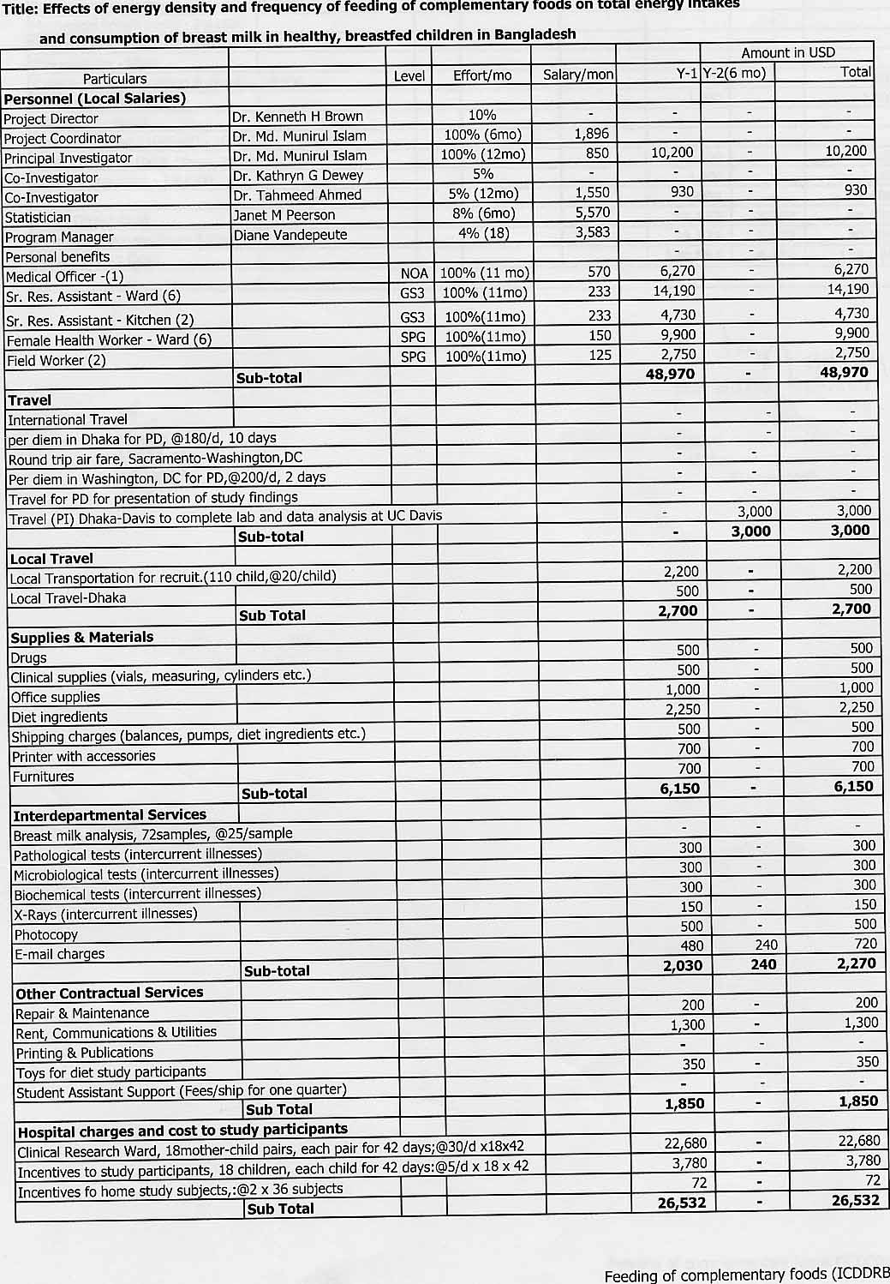
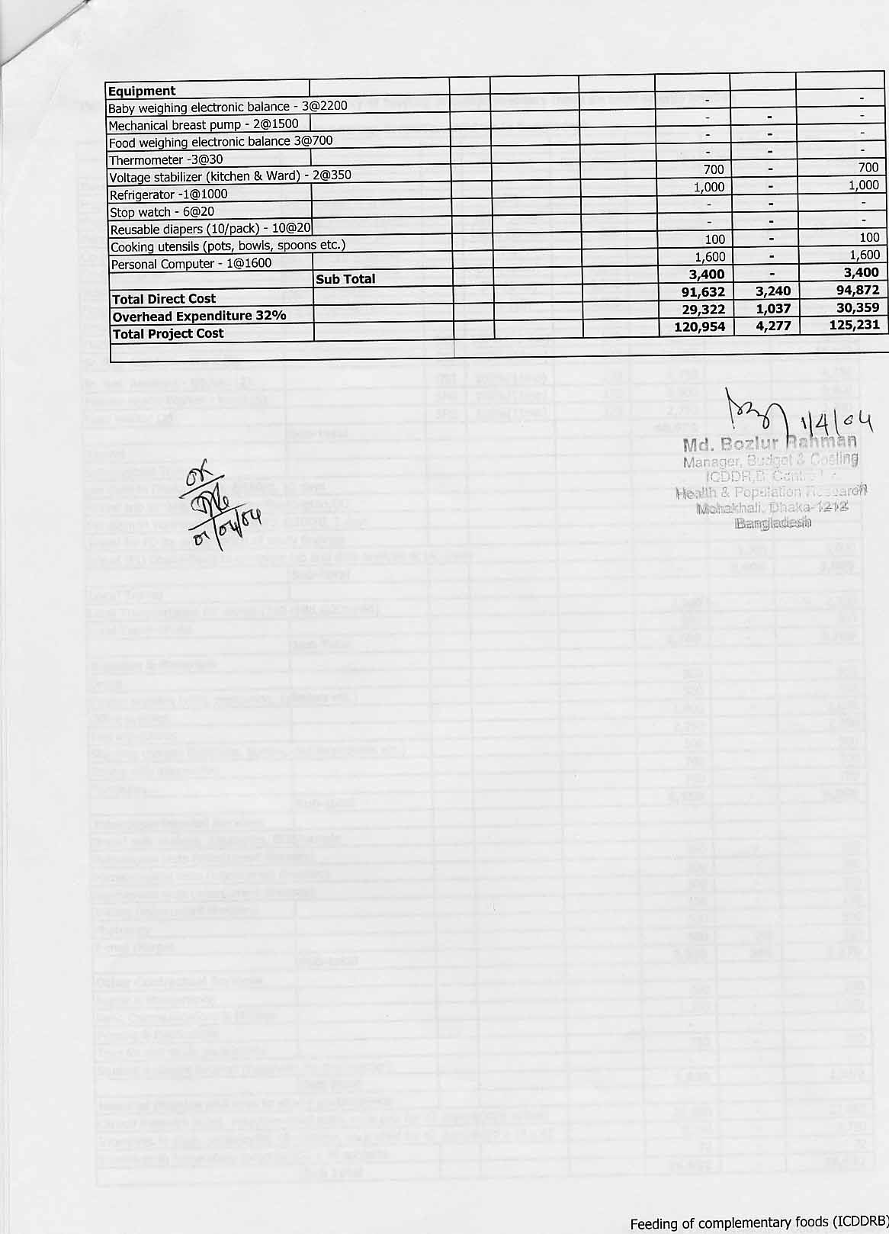
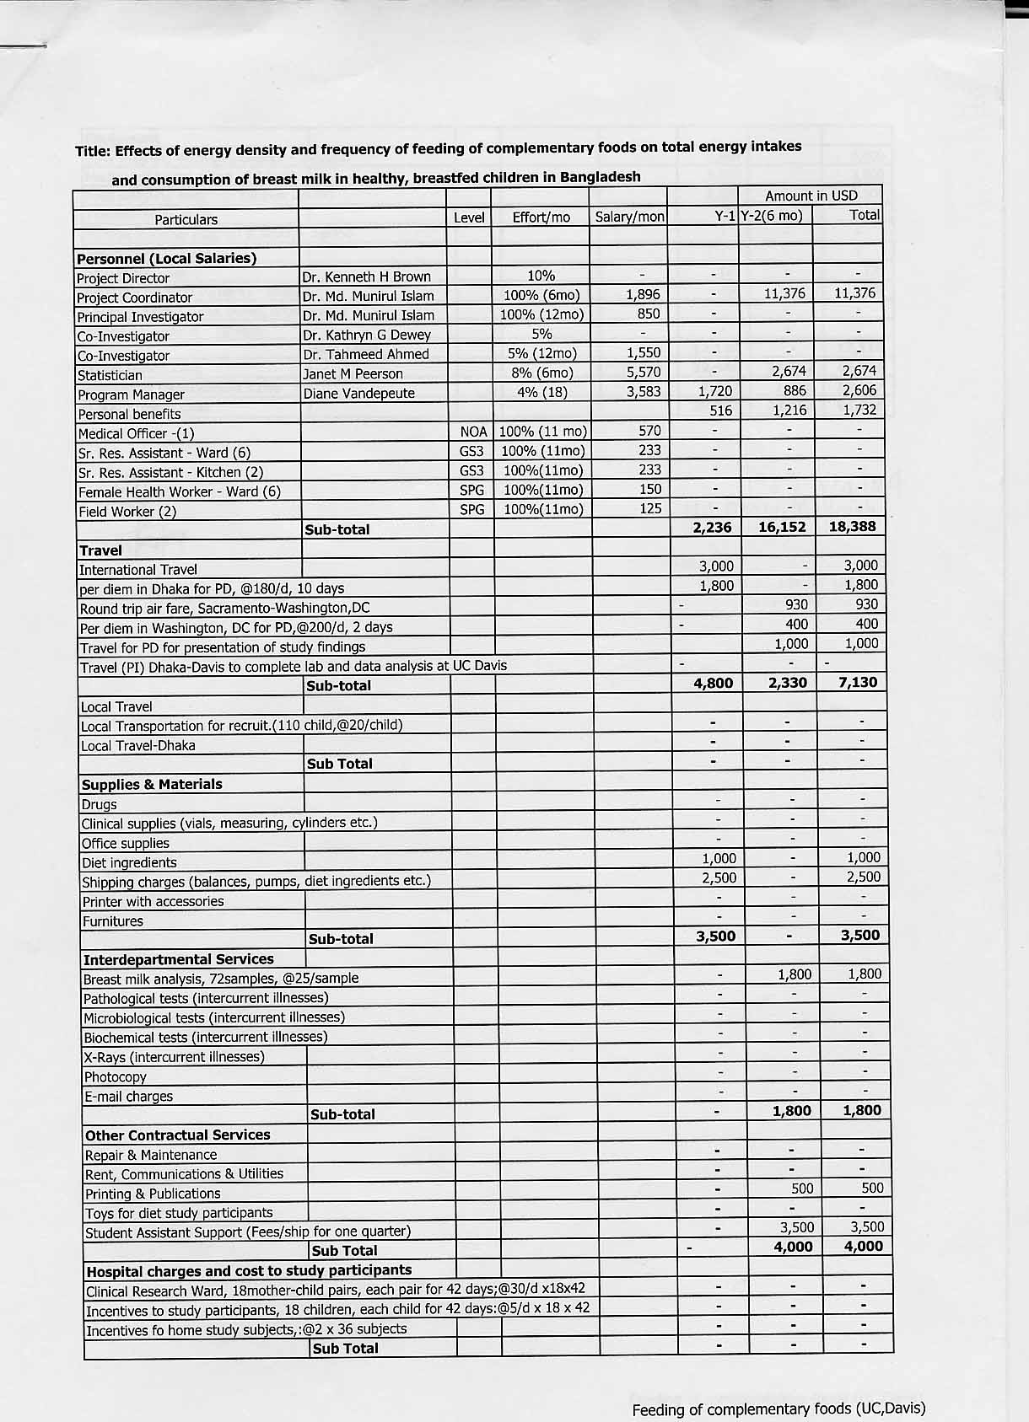
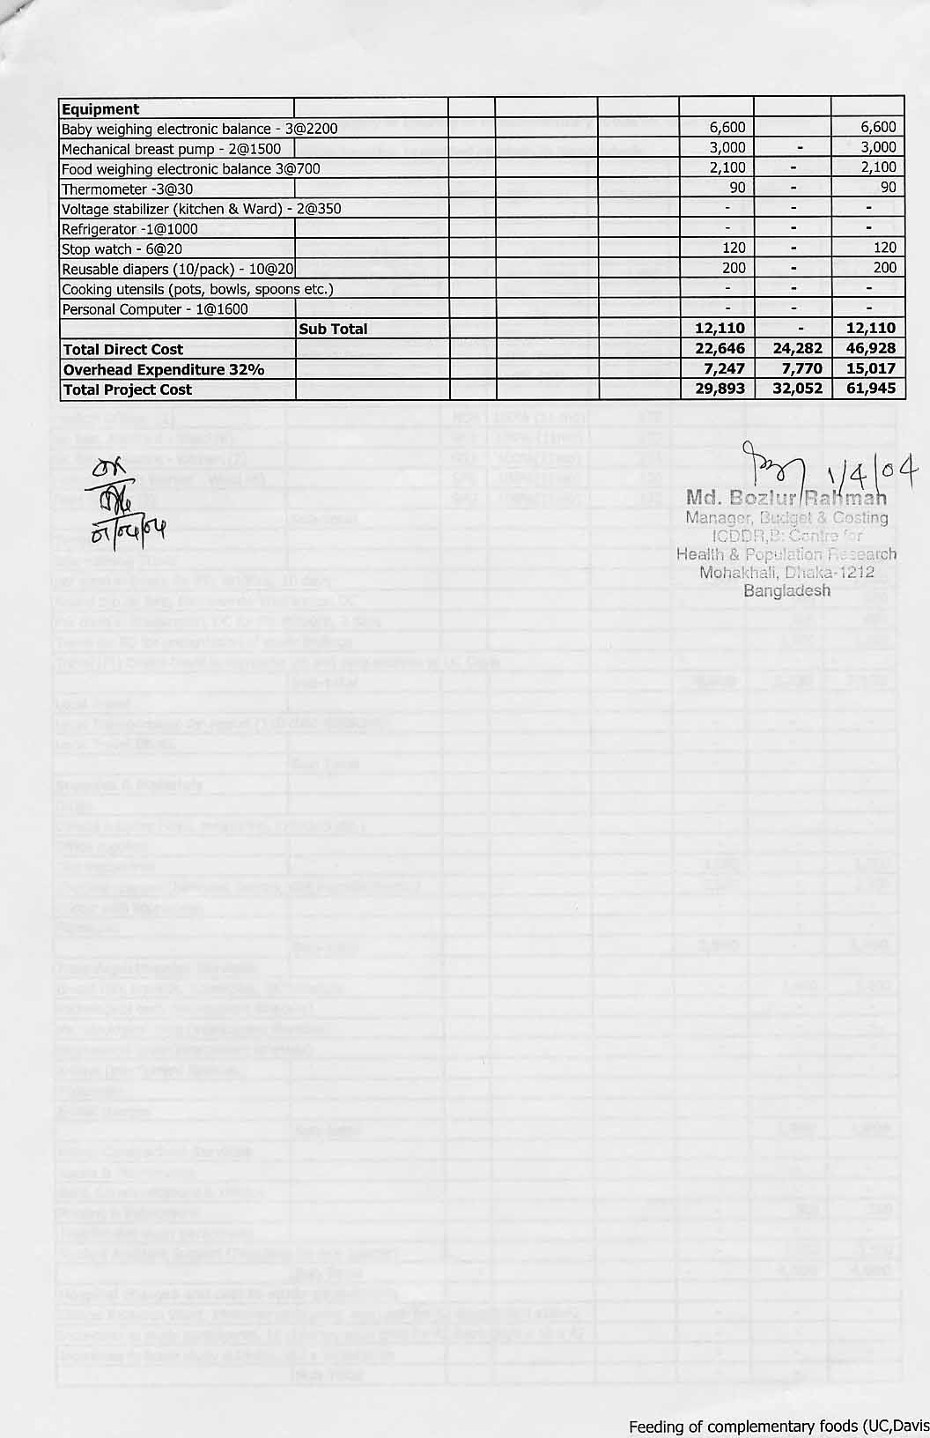
Budget Justifications

Please provide one page statement justifying the budgeted amount for each major item. Justify use of manpower, major equipment, and laboratory services.

Budget Justification UC Davis:

Personnel:

- Dr Kenneth H. Brown: Dr. Brown will be the Project Director/ Principal Investigator responsible for the study protocol. He will devote approximately 10% of his time to this effort, although this time is not charged against the budget.

- Dr Kathryn G Dewey: Dr Dewey will be the Co-Investigator of the project. She will devote 5% of her time to help the PD and PC by advising on the implementation of the study procedures, laboratory analysis of milk specimens, and analysis and interpretation of the data. Her time devoted to the project is not charged to the budget.

- Dr Md Munirul Islam: Dr. Islam will be the Project Coordinator (PC) responsible for day-to-day supervision of the study protocol in Bangladesh, including training and supervision of project staff, provision of care to the patients, data review and management, analysis and report/manuscript writing. He will also be responsible for coordination between the ICDDR,B and UC Davis. He will devote 100% of his time for to the study for the entire 18 months’ duration. Dr. Islam is a clinical staff member at ICDDRB and a PhD student at UC Davis. He will be completing this study as part of his doctoral dissertation. During year 1 he will be paid by ICDDRB through its sub-contract. In year 2 he will be paid directly by UC Davis.

- Janet M. Peerson: Ms. Peerson is the Senior Statistician of the Program in International Nutrition at UC Davis. She will be responsible for guiding the statistical analysis, and she will devote a total of two weeks to this task.

- Diane Vandepeute: Ms. Vandepeute is the Administrative Assistant of the Program in International Nutrition at UC Davis. She will be responsible for developing a subcontract between UC Davis and ICDDRB, transferring funds between institutions, reconciling accounts, and managing other logistics, such as travel, shipping, etc. 4% of her time will be dedicated to these tasks.

Equipment:

- Baby-weighing electronic balance, one-gram precision: Three balances will be used for test weighing. One will be used continuously in the study ward and one will be used for the home dietary studies. The third will be used for back up in case of any breakdowns or a need to complete two studies on the same day in the community.

- Mechanical breast pumps: Two hospital grade electrical breast pumps will be used for expression of breast milk. One is assigned for continuous use and the other will be available for emergency back up.

Materials and supplies:

1. Food-weighing electronic balance, one gram precision: Three balances will be required for weighing the study
diets. One each will be used in the study kitchen for preparation of the study diets, one will be used in the
research ward to measure intakes, and one will be used in the community studies.

- Thermometer: Three thermometers will be needed for the temperature-controlled cooking procedures of the
study diets.

- Stop watches: Six stopwatches will be needed for recording the feeding and breast feeding time.

- Reusable diapers: These will be used during test-weighing to avoid any loss of stool or urine during breast feeding episodes.

6. Diet ingredients: Rice starch and non-caloric sweeteners will be purchased in the USA as they are not available
in Bangladesh. Other dietary ingredients will be procured in Bangladesh.

7. Shipping charges: This includes the shipping charges for sending the balances, pumps, diet ingredients from
the USA to Bangladesh and to send the breast milk samples from Bangladesh to Davis.

8. Breast milk analysis: self-explanatory.

Travel:

1. Dr. Brown will travel to Bangladesh for ten days to assist Dr. Islam with the implementation of the project. One round-trip airfare from Sacramento to Dhaka and ten days per diem are budgeted to cover Dr. Brown’s travel.

2. One trip to Washington, DC and two days of per diem are budgeted to allow PD to attend USDA investigators
meeting, as suggested in RFP, and one trip is budgeted for presentation of study results at a scientific
conference.

Printing and Publication:

Journal page charges for two articles.

Student Assistant Support:
Fees and insurance in year 2 for Munirul Islam, the project coordinator. After completion of the clinical phase of the
study, the project coordinator will travel to Davis to assist with laboratory analysis of milk specimens and to analyze
data and prepare the final report. The project coordinator is a Bangladeshi PhD student in the Program in
International Nutrition, Department of Nutrition, UC Davis.

Indirect Costs:
Indirect costs are calculated using the off-campus rate of 26% for modified direct costs, because this amount is less
than the indirect costs would be if we used the USDA rate of 19% of total costs.

Budget Justification ICDDRB:

Personnel:

1. Munirul Islam – see above under UC Davis budget

2. Dr Tahmeed Ahmed will assist with coordination of the project at ICDDR,B. He is the director of the research
ward, and he will assist with project implementation and supervision of the clinical staff.

3. Medical Officer: A Medical Officer (to be appointed) will be responsible for subject recruitment and informed
consent procedures and clinical examination and management of the study subjects throughout the study. The
incumbent will participate in field visits during the home dietary studies to help supervise the field staff and will
assist the PC in data entry and data cleaning. Full time effort will be required during the clinical phase of the
study.

4. Senior Research Assistants (Clinical Research Ward): These six assistants will work in the Clinical Research
Ward and will be responsible for a) supervising the activities of the health workers and kitchen assistants, recording information on the pre-coded forms each day, and c) completing anthropometric assessments in the study ward. The same assistants will also travel to the study community on a rotational basis to perform the 12-h dietary observations in the children’s homes. Six persons are required to cover 2 shifts in the ward each day (two persons/shift, 6am-2pm and 2pm-10pm), considering holidays and vacation time.

- Senior Research Assistants (Kitchen): These assistants will work in the metabolic kitchen to prepare the study
diets, dispense them in pre-coded containers to the Clinical Research Ward, and maintain all appropriate records. One kitchen assistant will be available during each of two daytime shifts, seven days per week, necessitating a total of three staff members in this category.

- Female Health Workers (Clinical Research Ward): Six female health workers will be responsible for helping the research assistants in cooking, supervising the mothers and children during feeding, test-weighing for breast milk intake and assisting with breast milk expression. One person each will be assigned to the morning and evening shifts, and two will be required for the night shifts.

7. Field Workers: Two persons will be hired to conduct the census in the study community. They will be responsible for identifying potential study subjects and accompanying them to the research ward for further evaluation and admission to the study.

Equipment:

1. Refrigerator: One refrigerator will be needed for storing study diets prior to serving to the study participants
and for storing breast milk samples during the days of milk expression.

2. One desktop computer, printer, and accessories will be needed for the data entry, editing and analysis. Furniture will be needed to set up a separate study ward for conducting this study with adult subjects.

Materials and supplies:

1. Voltage stabilizer: Voltage stabilizers will be used with one of the baby weighing scales on the study ward and
with the food weighing scale in the metabolic kitchen.

2. Cooking utensils: These will be used for cooking and dispensing the study diets.

3. Medicines: Medicines will include the multi-micronutrient mixtures that will be provided routinely to the children. In addition, other medicines will be provided, as needed, for intercurrent illnesses.

4. Diet ingredients – covers materials for children’s study diets.

5. Clinical supplies – as explained.

6. Toys for diet study participants: This will be required while conducting the two-12 hours observational study,
and will be presented to the children as gifts after staying in their homes.

7. Costs of paper/printing for data collection forms.

8. Shipping – costs of sending breast milk samples to UC Davis for laboratory analysis.

Local Travel:

- Local transportation for recruitment: This will cover a) the costs of transporting the mothers and children to the Clinical Research Ward for initial evaluation and returning to the ward subsequently if found to be eligible for study, and b) the cost of conveying the study personnel who will conduct the initial census and the home dietary studies. In our preliminary study for recruiting 10 children, we had to screen 60 children, so we are expecting that to recruit 18 children we have to screen ~110 children. It is estimated that $20/child will be needed.

2. Local travel within Dhaka: These expenses are to allow the Project Director/Project Coordinator to visit the field site.

3. International travel for Munirul Islam to travel to UC Davis at end of clinical phase of study, as explained above.

Other direct charges:

- Repair and maintenance: Self explanatory.

- Rent, communication and utilities: This covers the fax, telephone, DHL, courier, postage etc.

3. Other laboratory investigations: This may be needed for any intercurrent illnesses of the child or the mother.
These include pathological, microbiological, and biochemical tests, and X-Rays.

4. Hospital charges: The hospital charges @30/day covers the cost of housing the mothers and children on the
study ward, and includes the costs of ward nurses (required in case of any intercurrent illness), meals for mothers, laundry, maintenance, etc.

5. Incentives to study participants: An incentive of $5/day will be provided to the mothers to enable them to stay
in the study facility for prolonged periods without losing any usual income from other sources.

Time line of the study

Task | ICDDR, B (Dhaka, Bangladesh) |  |  |  |  |  |  |  |  |  |  |  | UC Davis, USA |  |  |  |  |  | Persons  Responsible
Task | Study plan by month |  |  |  |  |  |  |  |  |  |  |  |  |  |  |  |  |  | Persons  Responsible
Task | 1 | 2 | 3 | 4 | 5 | 6 | 7 | 8 | 9 | 10 | 11 | 12 | 13 | 14 | 15 | 16 | 17 | 18 | Persons  Responsible
Staff Recruitment |  |  |  |  |  |  |  |  |  |  |  |  |  |  |  |  |  |  | Personnel Department, PI, Co-I
Staff Training |  |  |  |  |  |  |  |  |  |  |  |  |  |  |  |  |  |  | PI & Co-I
Conducting census |  |  |  |  |  |  |  |  |  |  |  |  |  |  |  |  |  |  | FW
Study recruitment, home dietary studies |  |  |  |  |  |  |  |  |  |  |  |  |  |  |  |  |  |  | FW, SRA
Enrolment of study participants |  |  |  |  |  |  |  |  |  |  |  |  |  |  |  |  |  |  | PI, Co-I, MO, SRA, FW, FHW
Data Entry |  |  |  |  |  |  |  |  |  |  |  |  |  |  |  |  |  |  | PI, MO
Breast milk: Laboratory analyses |  |  |  |  |  |  |  |  |  |  |  |  |  |  |  |  |  |  | Laboratory Personnel
Statistical analyses |  |  |  |  |  |  |  |  |  |  |  |  |  |  |  |  |  |  | PD, PI &  Statistician
Report writing |  |  |  |  |  |  |  |  |  |  |  |  |  |  |  |  |  |  | PD & PI
PD=Project Director, PI=Principal Investigator, Co-I=Co-Investigator, MO=Medical Officer, SRA=Senior Research Assistant FHW=Female Health Workers,
and FW=Field Workers.
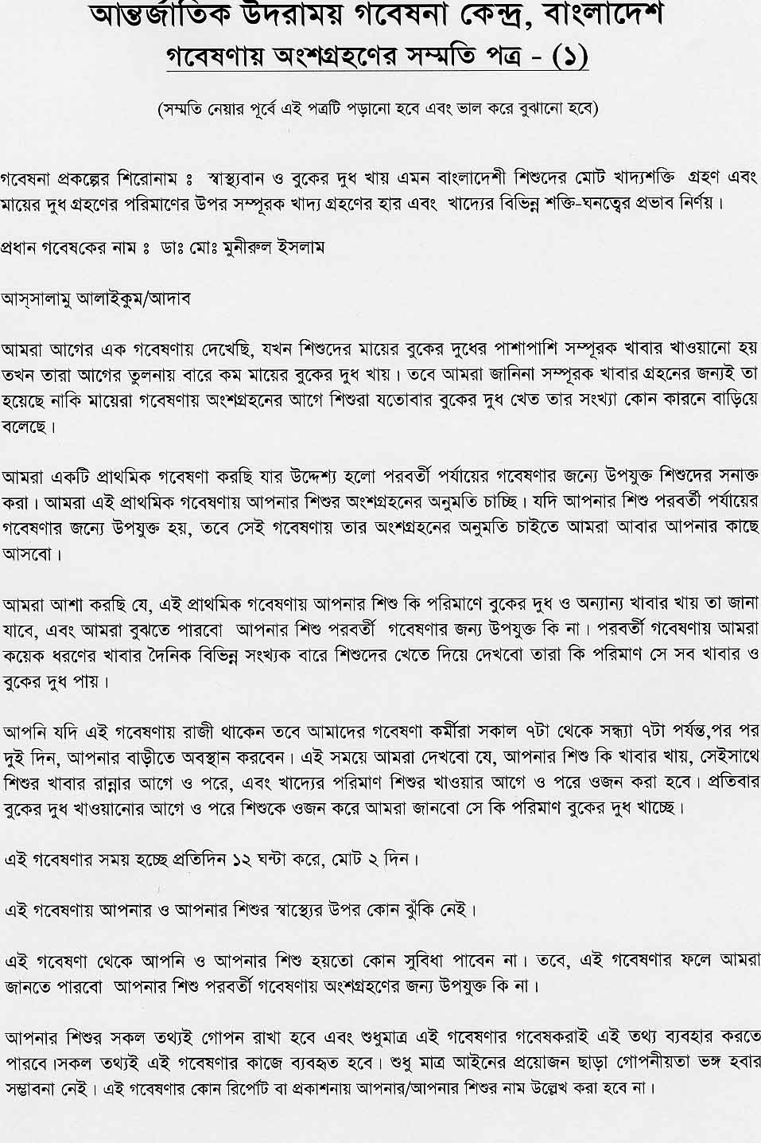

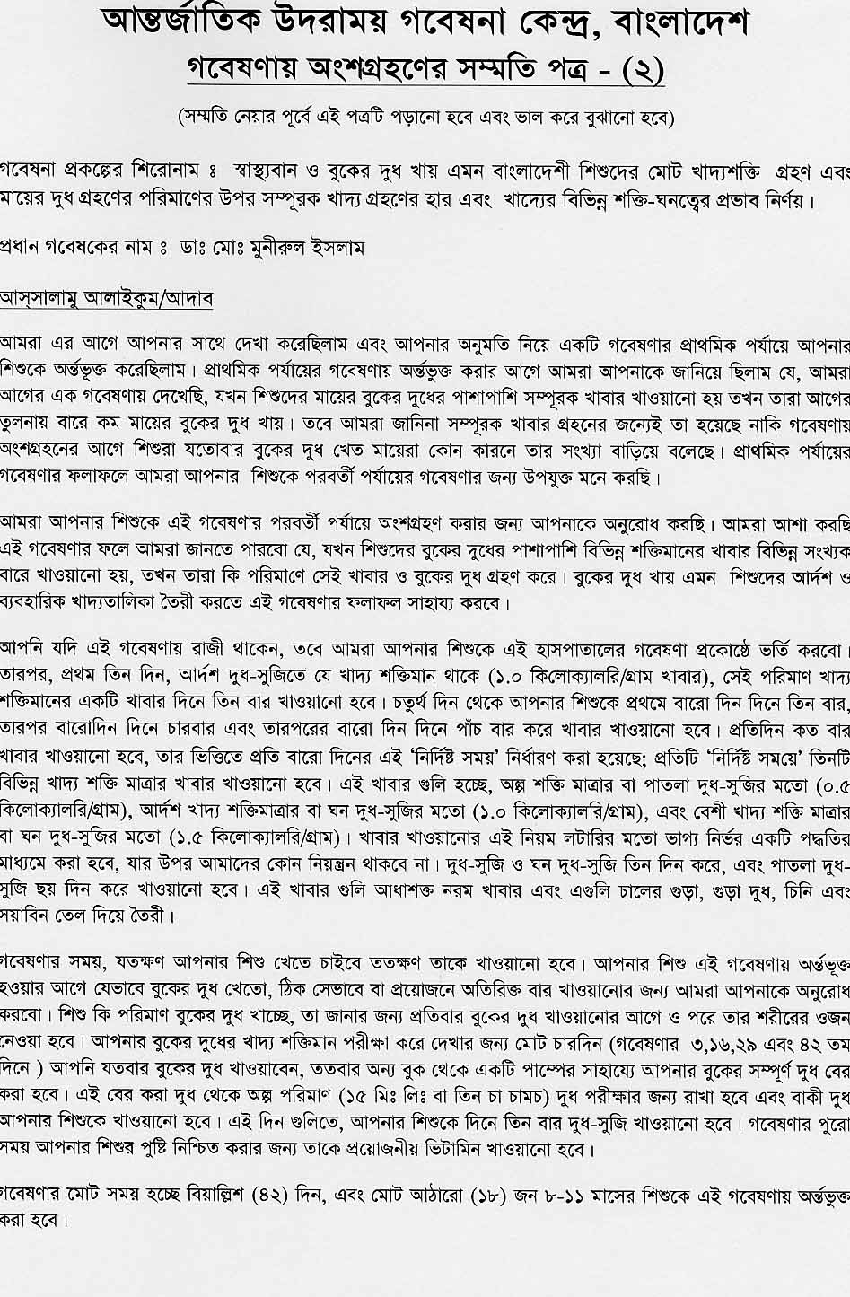
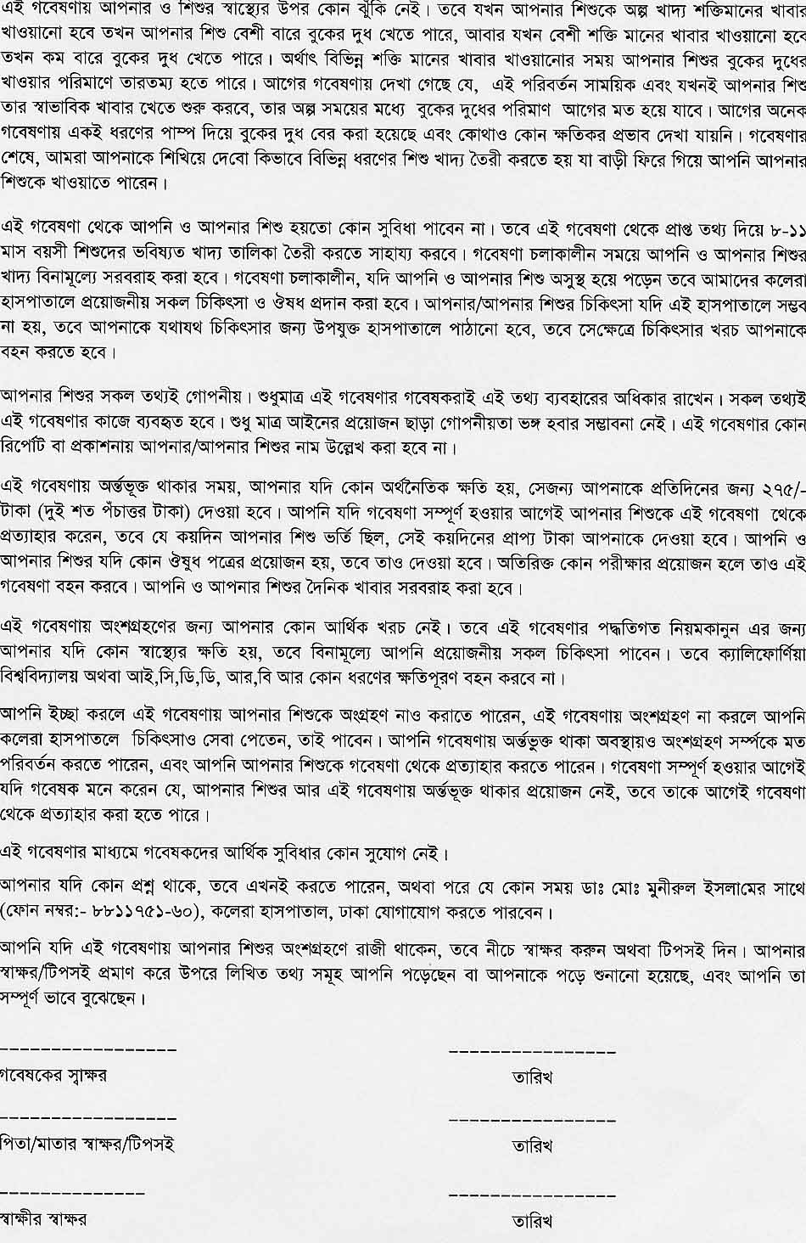

Check List

After completing the protocol, please check that the following selected items have been included.

- Face Sheet Included X

- Approval of the Division Director on Face Sheet X

- Certification and Signature of PI on Face Sheet, #9 and #10 X

- Table on Contents X

5. Project Summary X

- Literature Cited X

7. Biography of Investigators X

- Ethical Assurance X

- Consent Forms X

- Detailed Budget X

